EX NO: 1 PASSPORT AUTOMATION SYSTEM
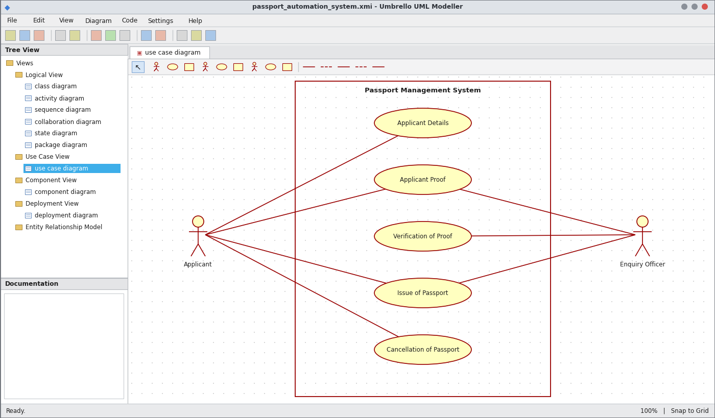
Use Case Diagram
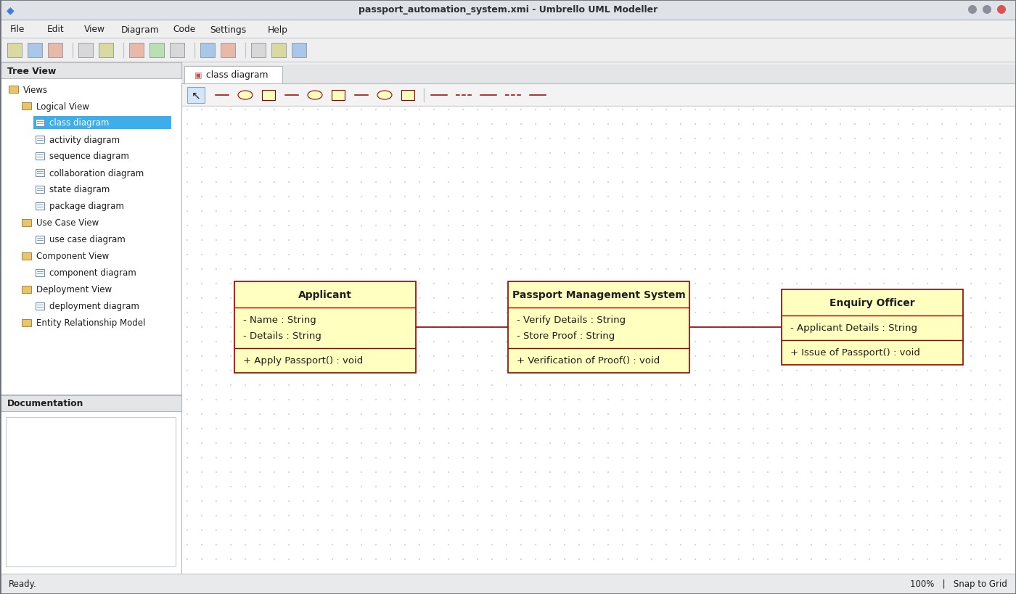
Class Diagram
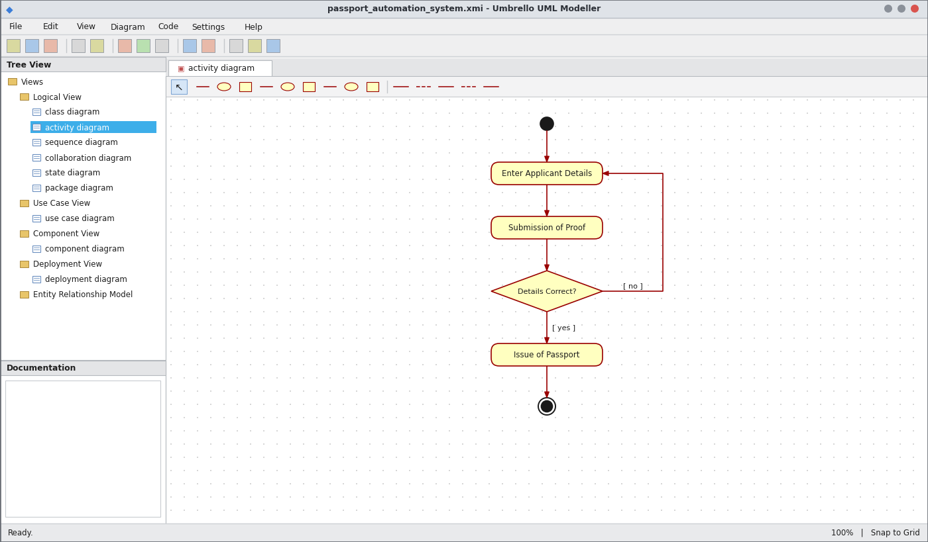
Activity Diagram
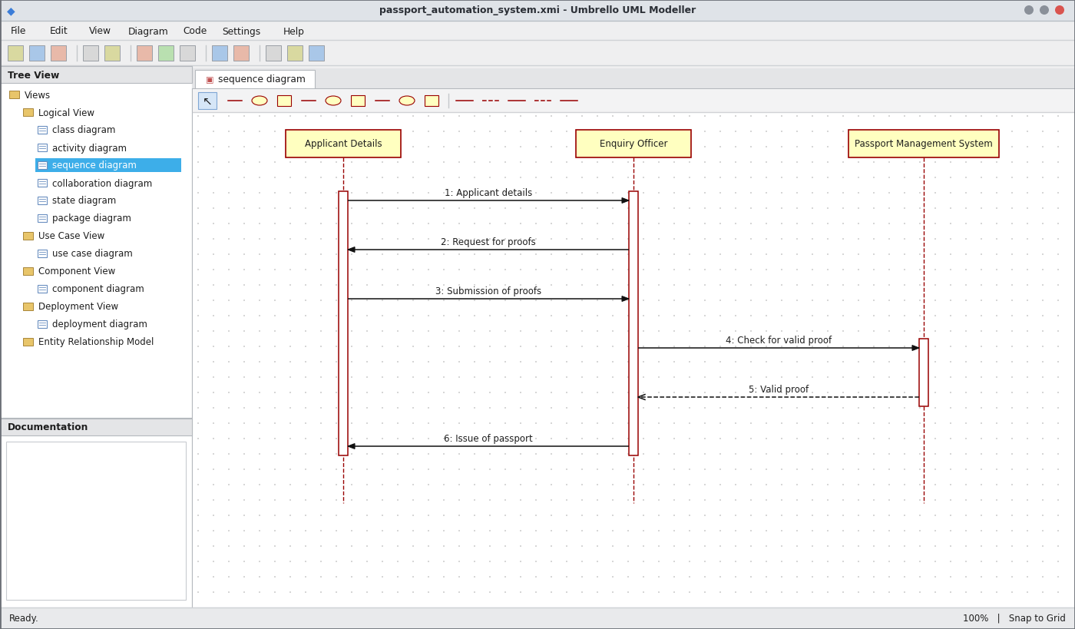
Sequence Diagram
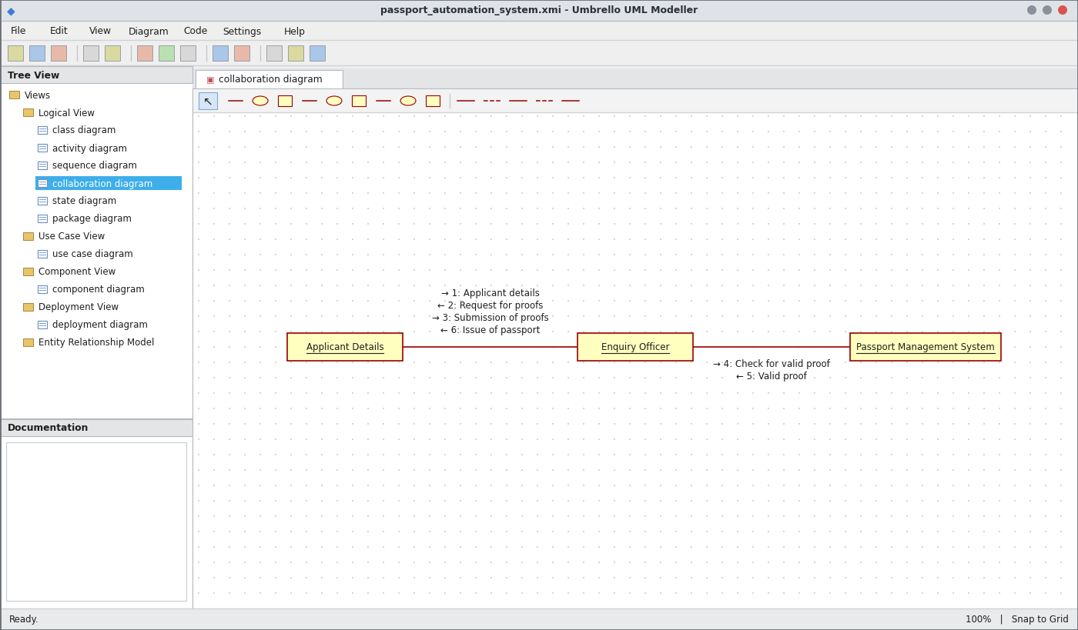
Collaboration Diagram
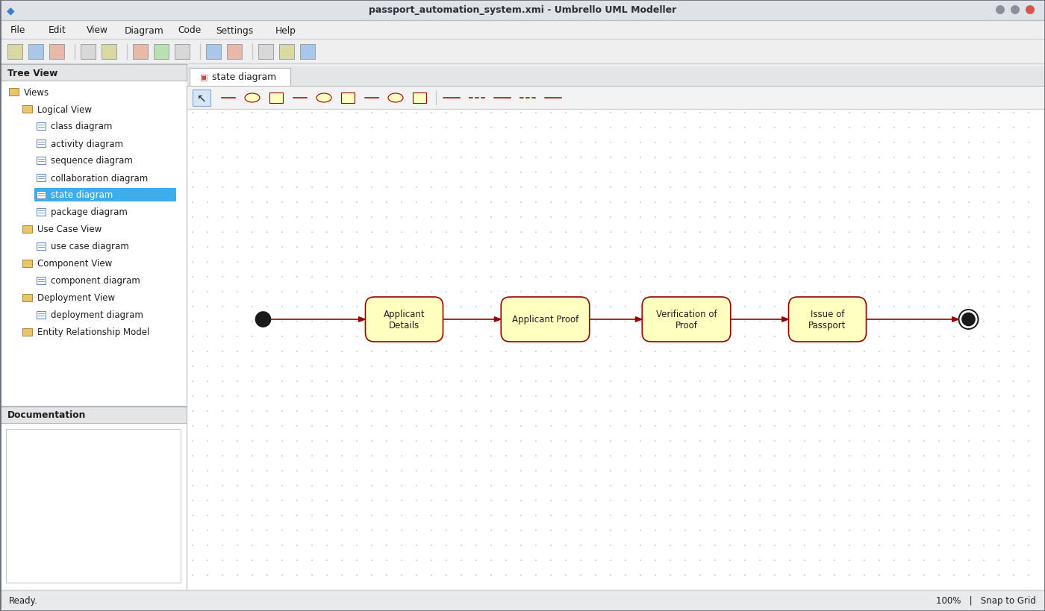
State Chart Diagram
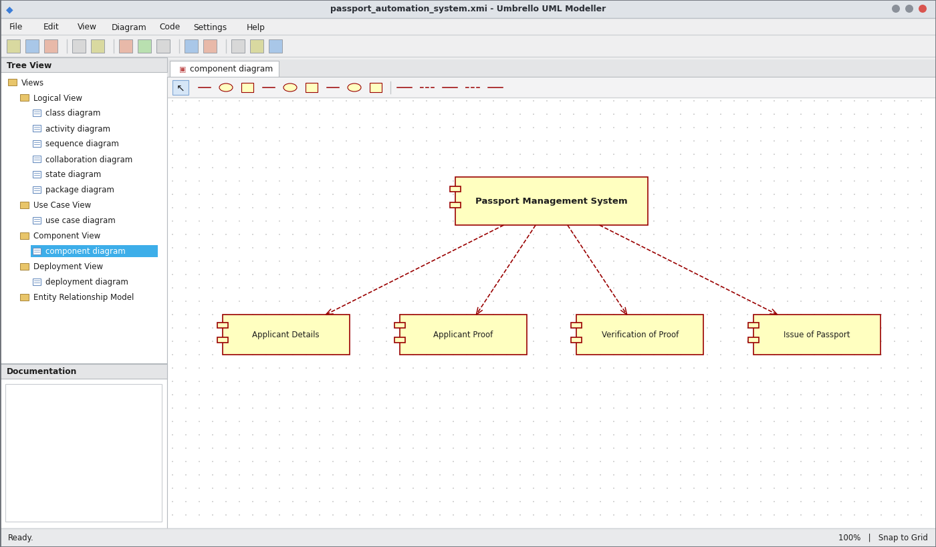
Component Diagram
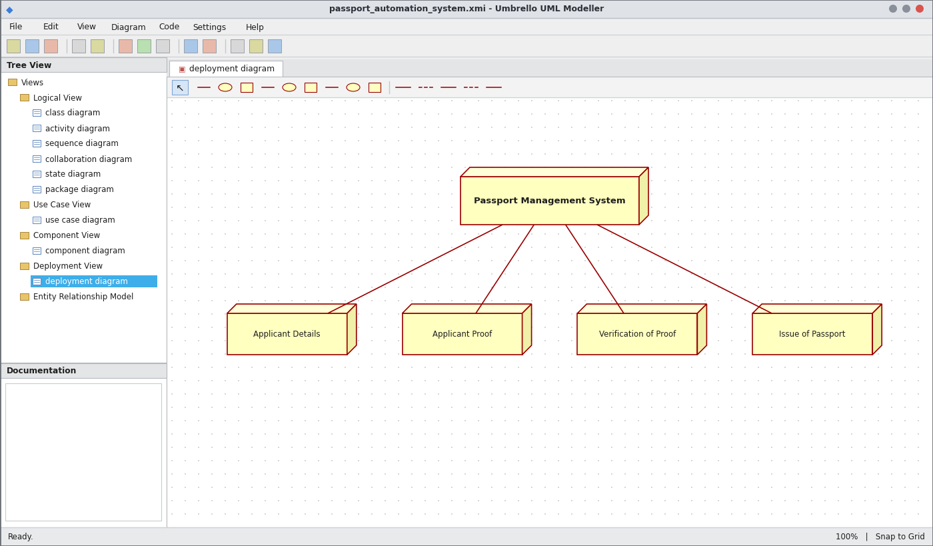
Deployment Diagram
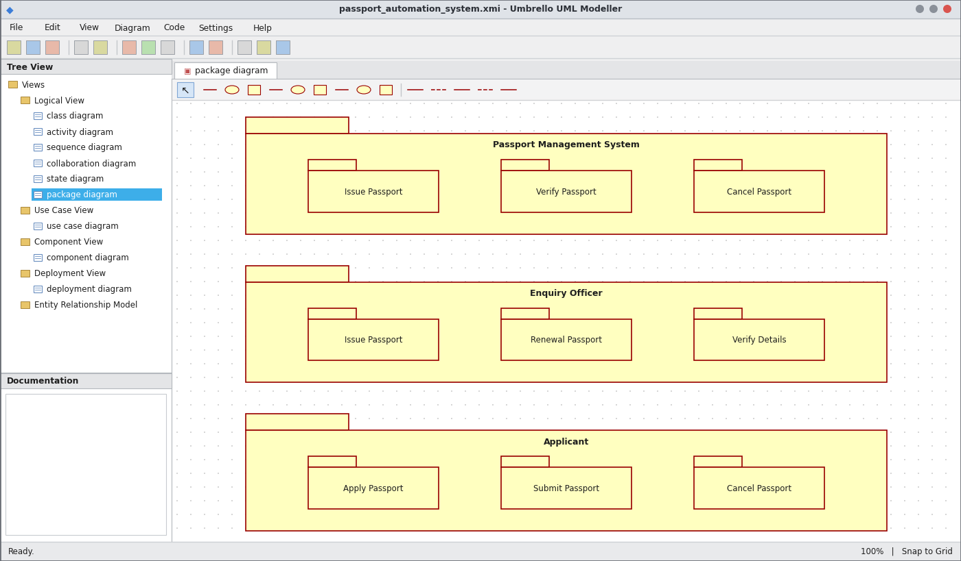
Package Diagram
WEBPAGE SCREENSHOT
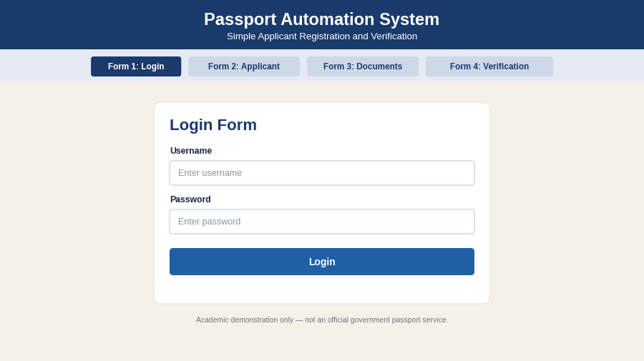
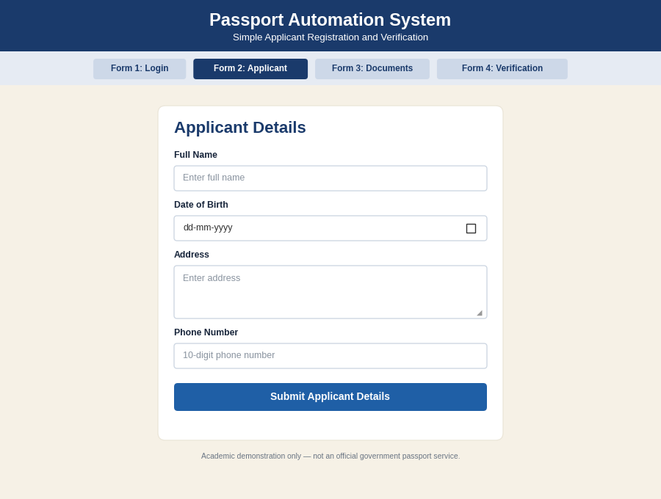
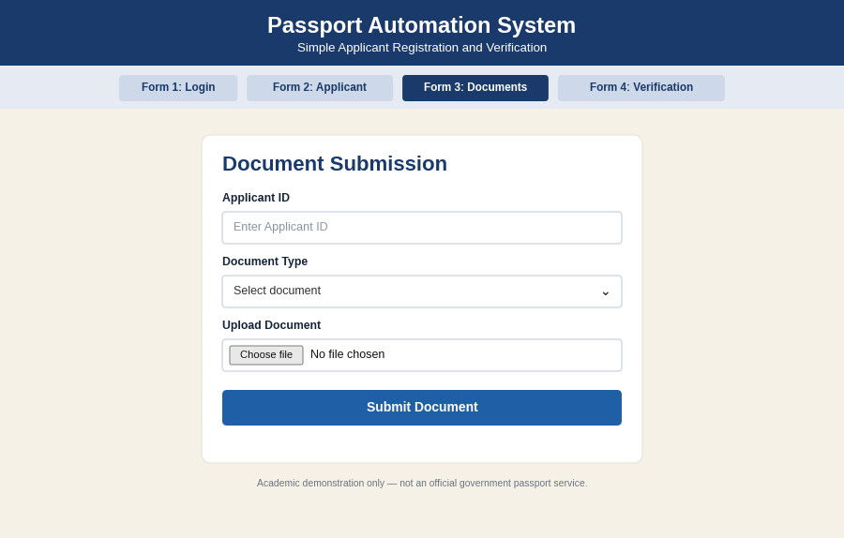
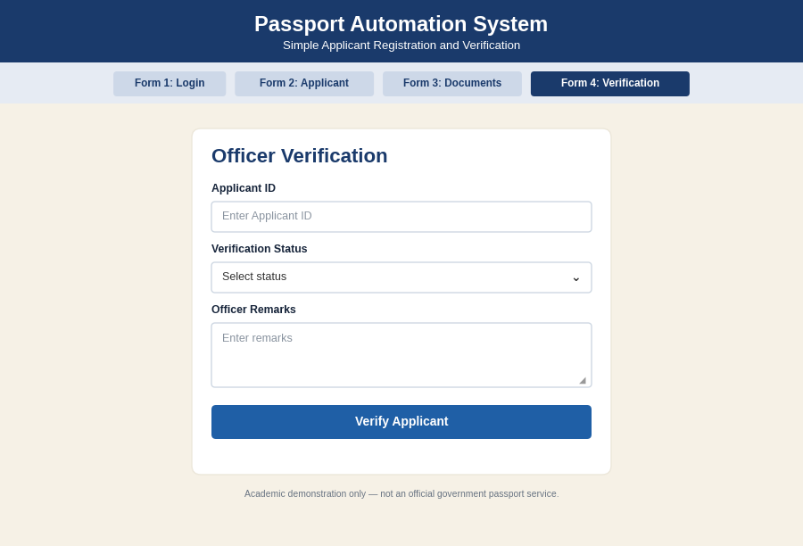
PSEUDO CODE
1. Applicant Registration
BEGIN
READ applicant name and details
STORE details in database
SUBMIT proof documents
DISPLAY "Application submitted"
END
2. Verification of Proof
BEGIN
FETCH applicant proof from database
IF proof is valid THEN
SET status = "Verified"
ELSE
SET status = "Rejected"; NOTIFY applicant
ENDIF
END
3. Issue / Cancellation of Passport
BEGIN
IF status = "Verified" THEN
GENERATE passport number
ISSUE passport to applicant
ENDIF
IF applicant requests cancellation THEN
CANCEL passport
ENDIF
END

EX NO: 2 BOOK BANK REGISTRATION SYSTEM
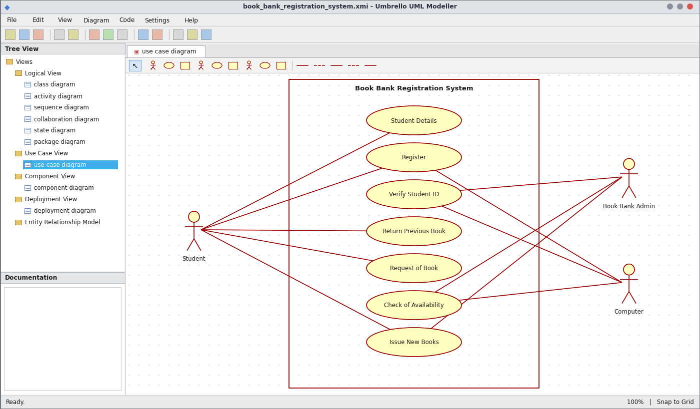
Use Case Diagram
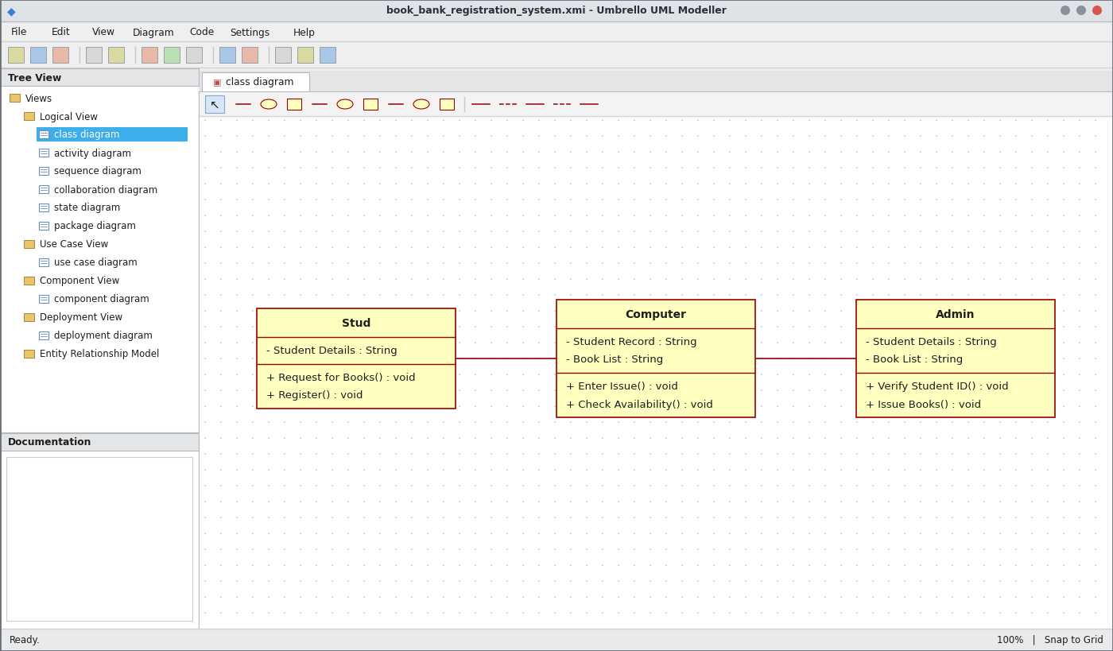
Class Diagram
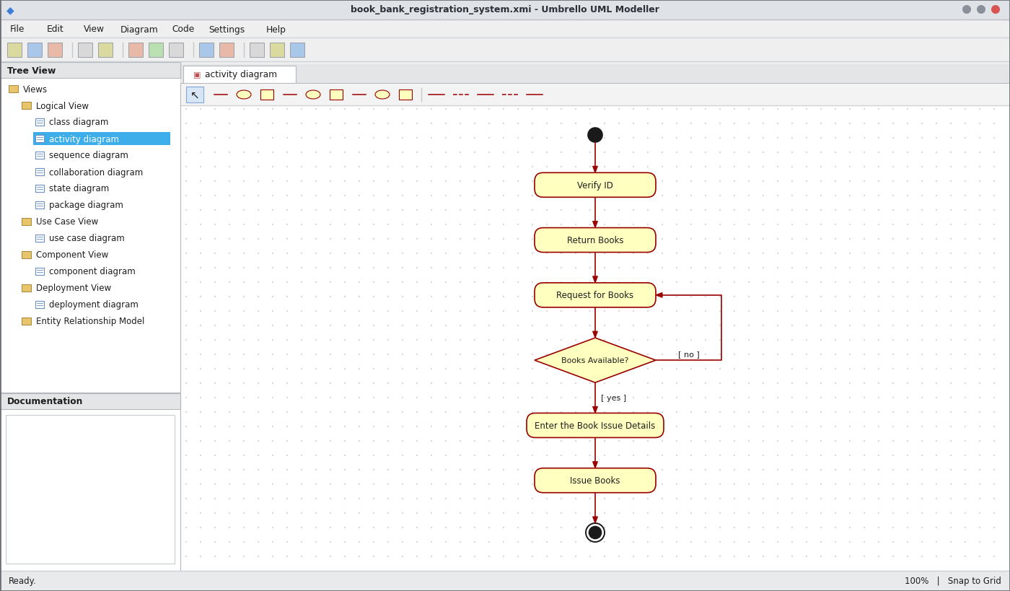
Activity Diagram
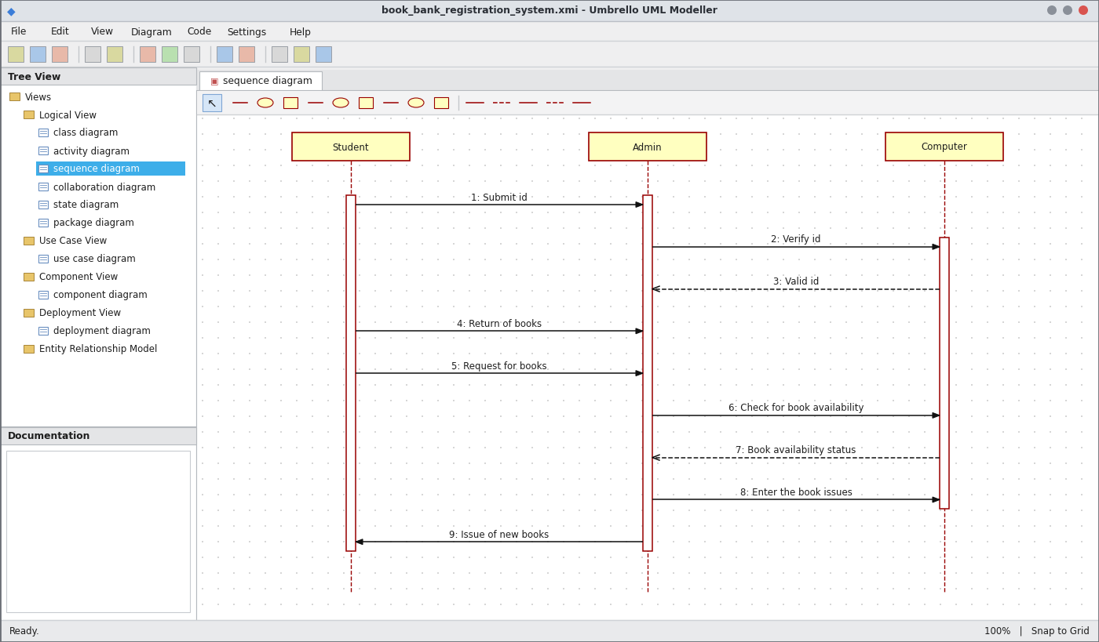
Sequence Diagram
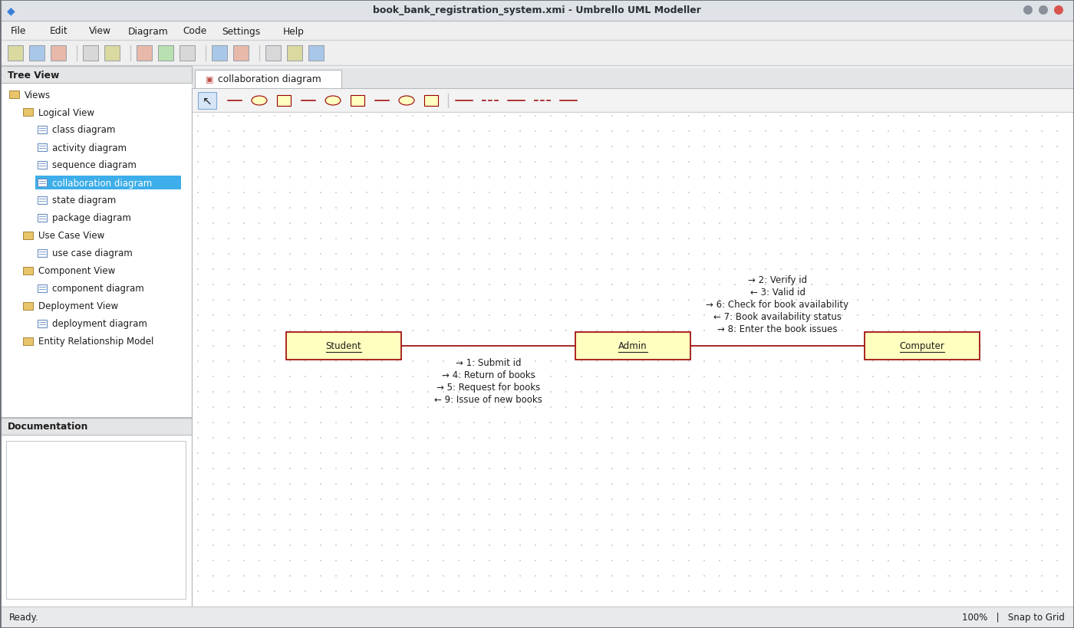
Collaboration Diagram
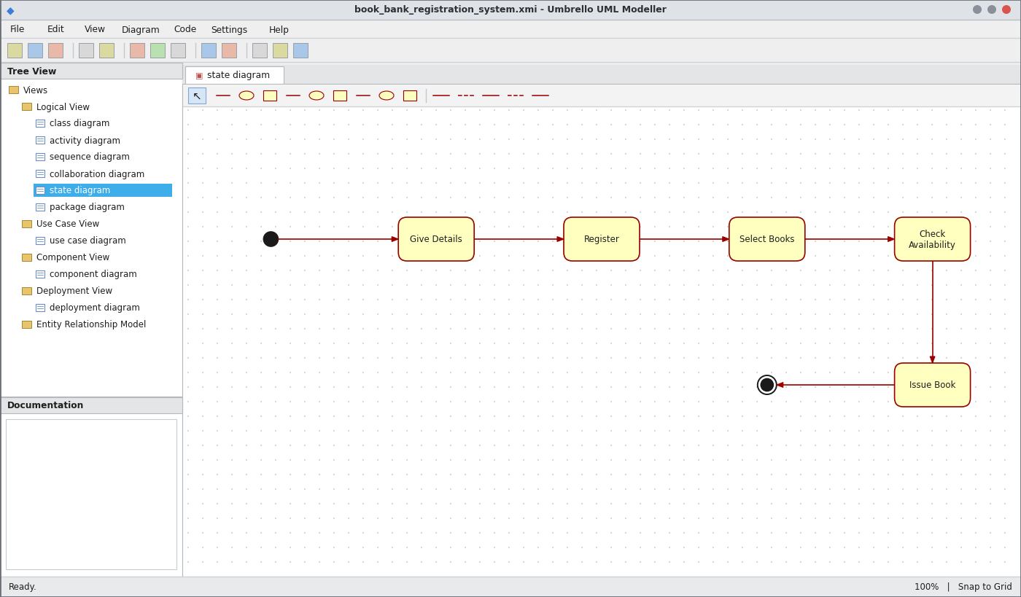
State Chart Diagram
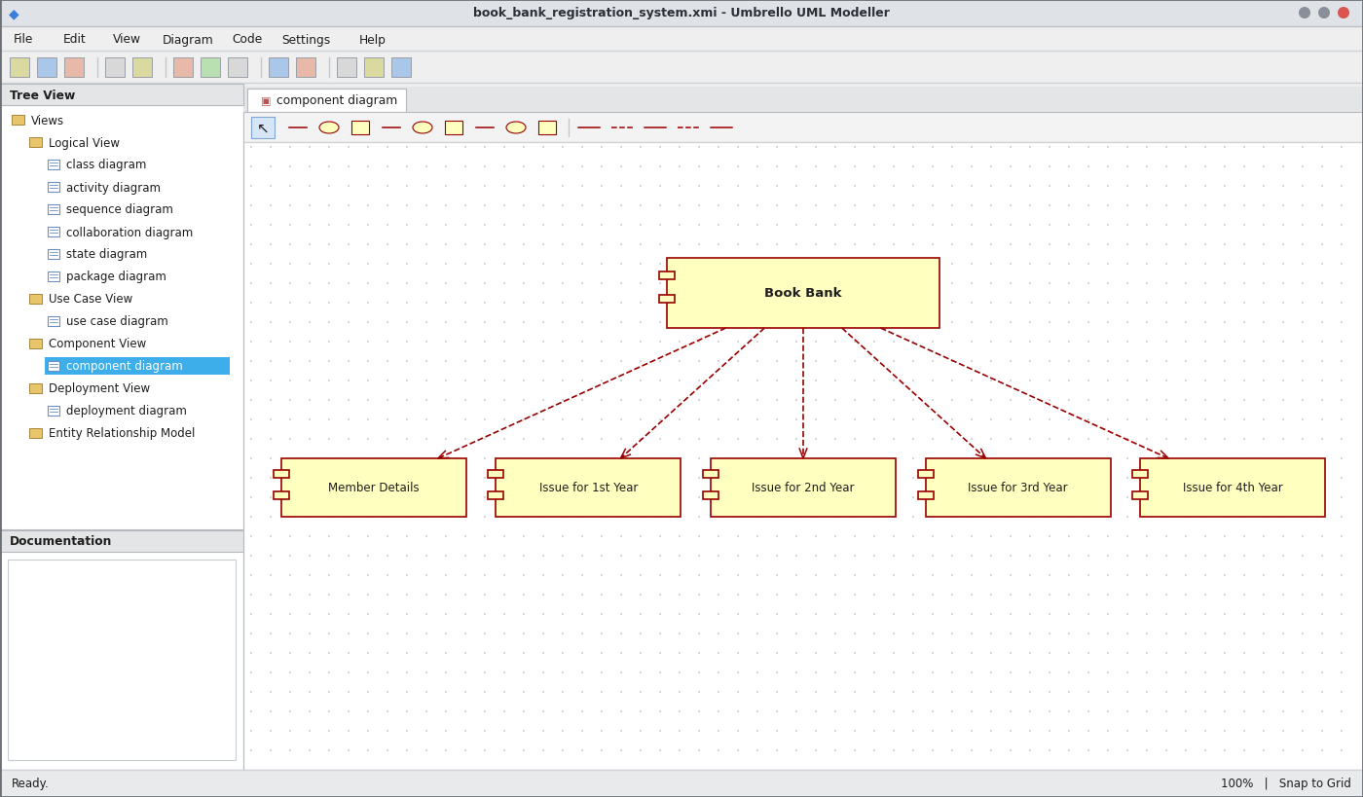
Component Diagram
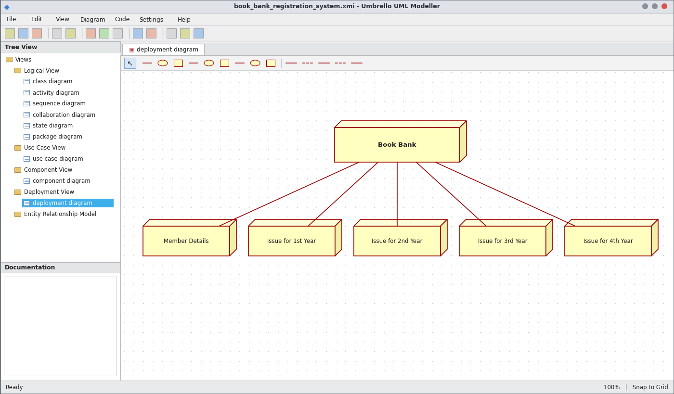
Deployment Diagram
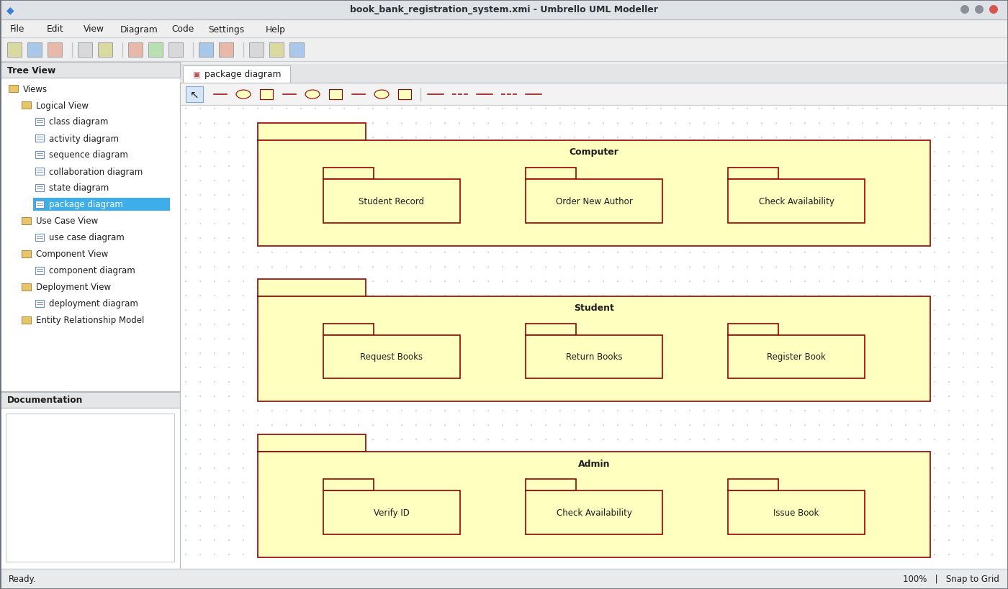
Package Diagram
WEBPAGE SCREENSHOT
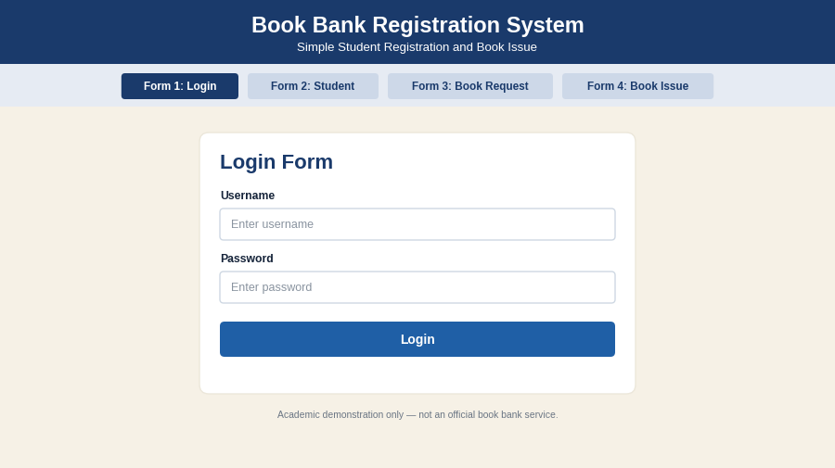
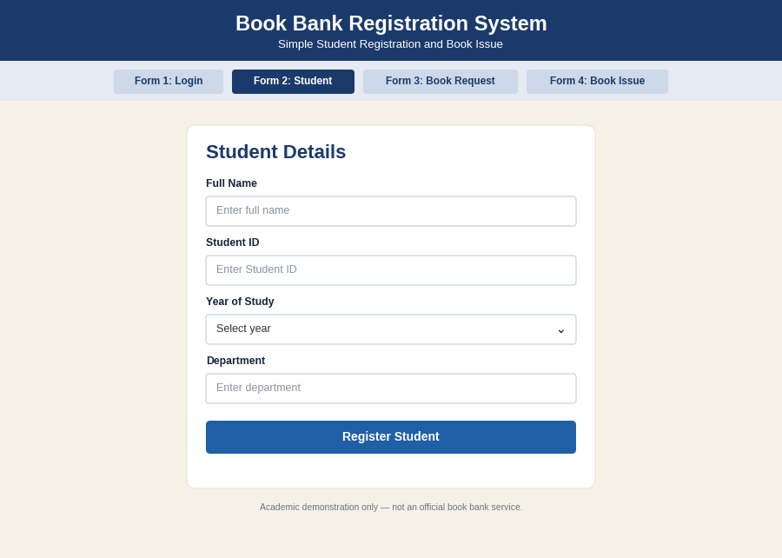
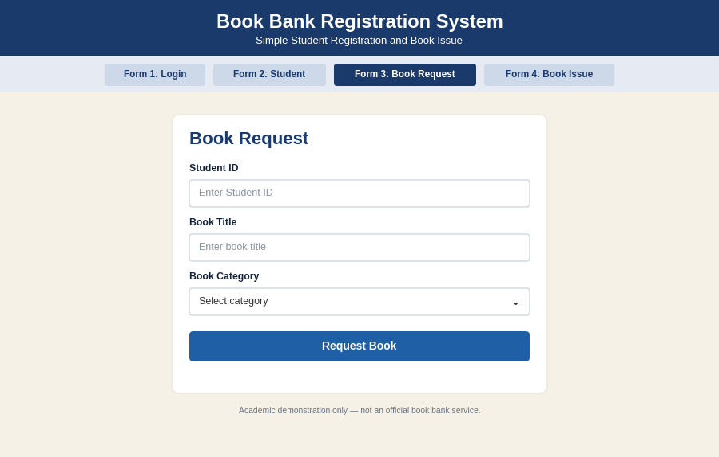
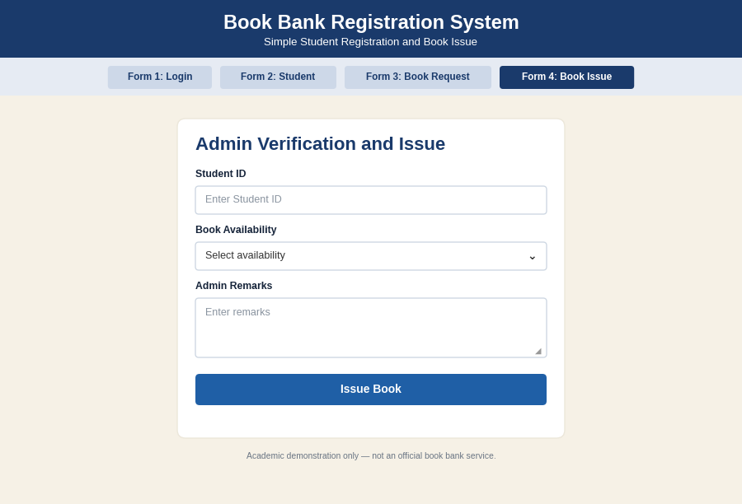
PSEUDO CODE
1. Student Registration and ID Verification
BEGIN
READ student details and student id
SEND id to computer for verification
IF id is valid THEN REGISTER student
ELSE DISPLAY "Invalid id"
ENDIF
END
2. Check Book Availability
BEGIN
ACCEPT return of previous books
READ requested book
SEARCH book list
IF book is present THEN SET available = TRUE
ELSE SET available = FALSE
ENDIF
END
3. Issue of Books
BEGIN
IF available = TRUE THEN
ENTER book issue details in system
ISSUE new books to student
UPDATE book list
ELSE
DISPLAY "Book not available"
ENDIF
END

EX NO: 3 EXAM REGISTRATION SYSTEM
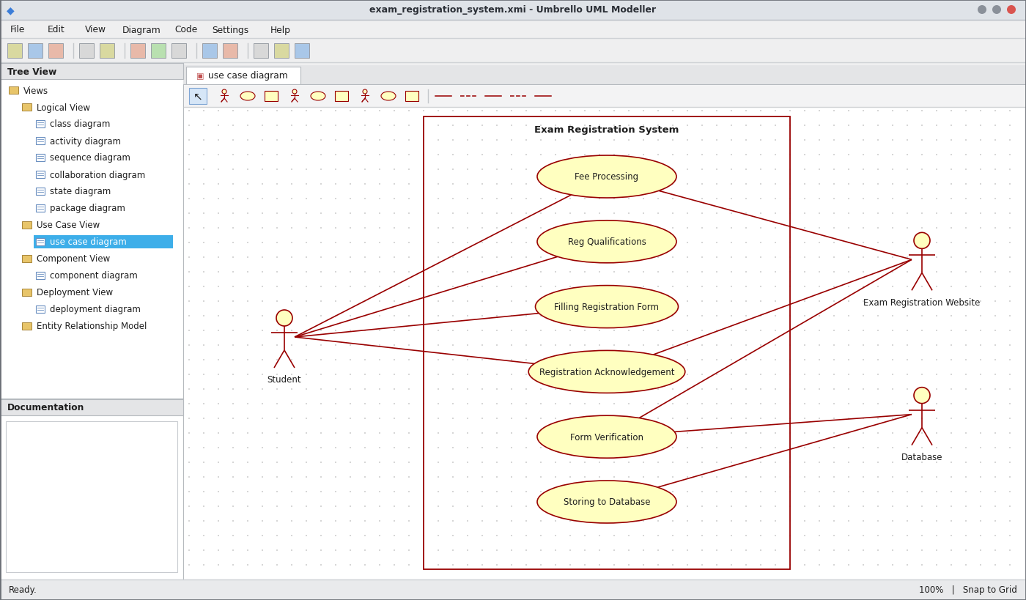
Use Case Diagram
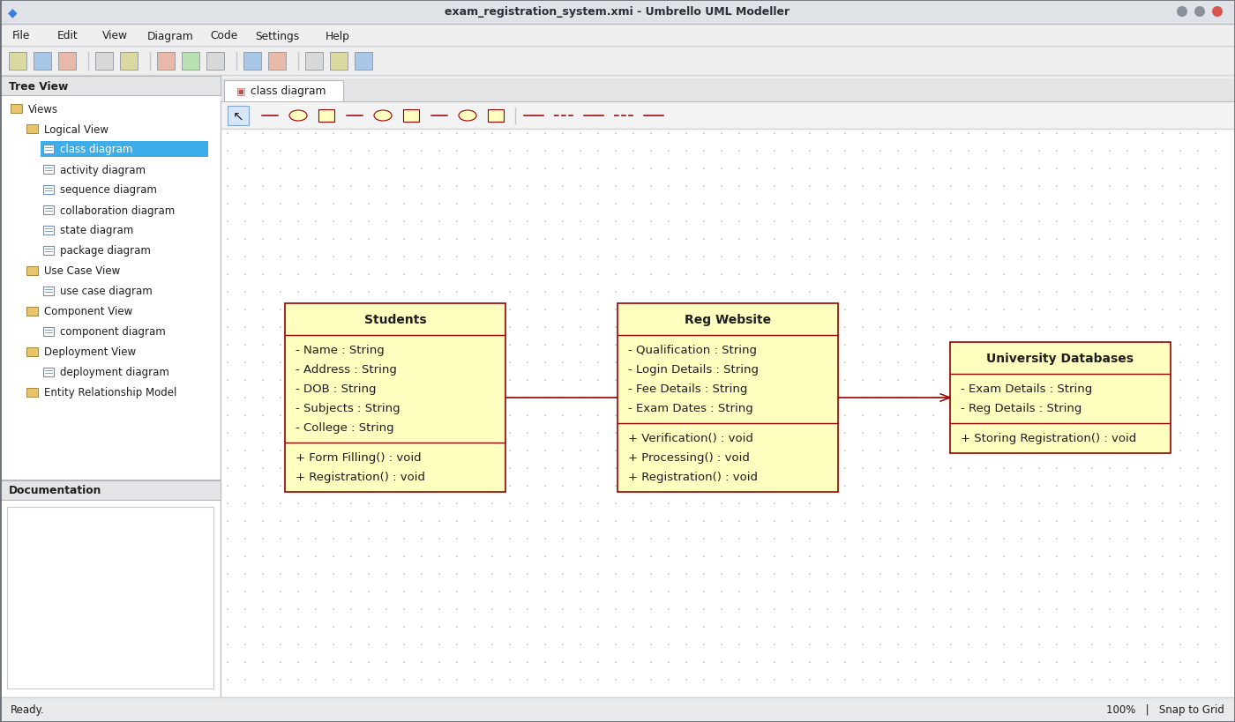
Class Diagram
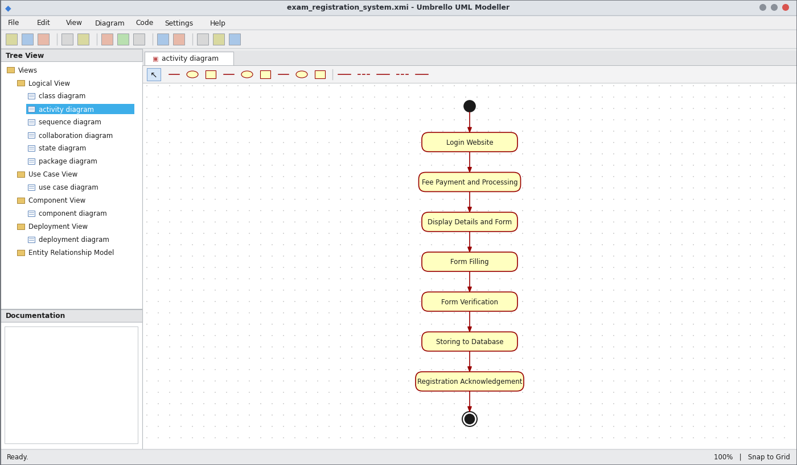
Activity Diagram
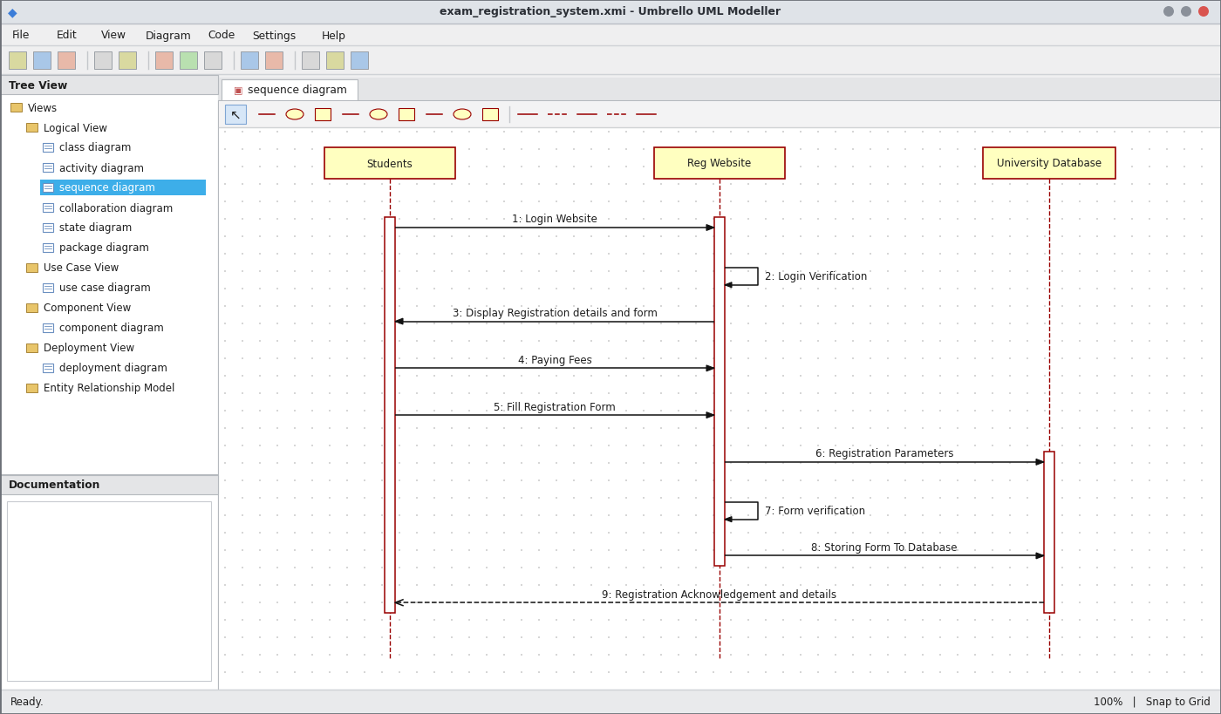
Sequence Diagram
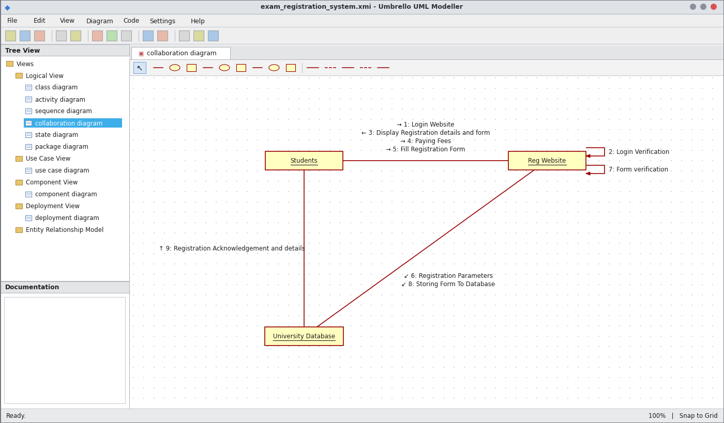
Collaboration Diagram
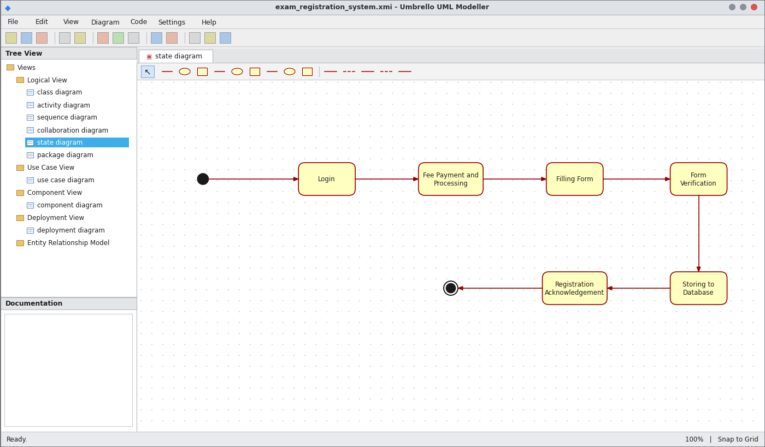
State Chart Diagram
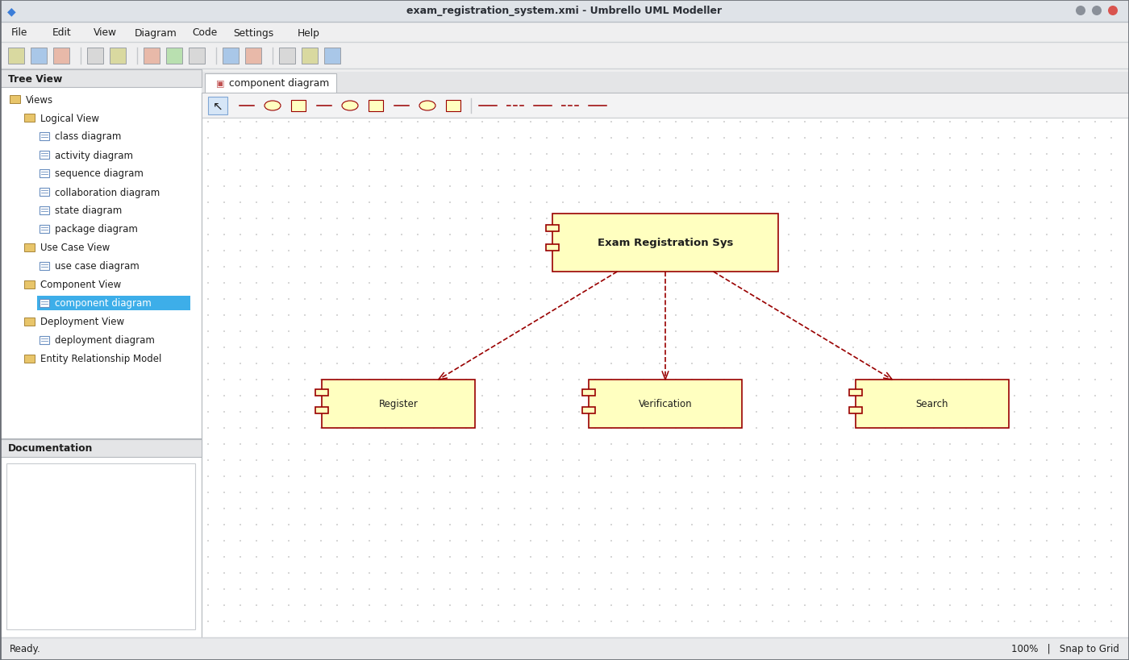
Component Diagram
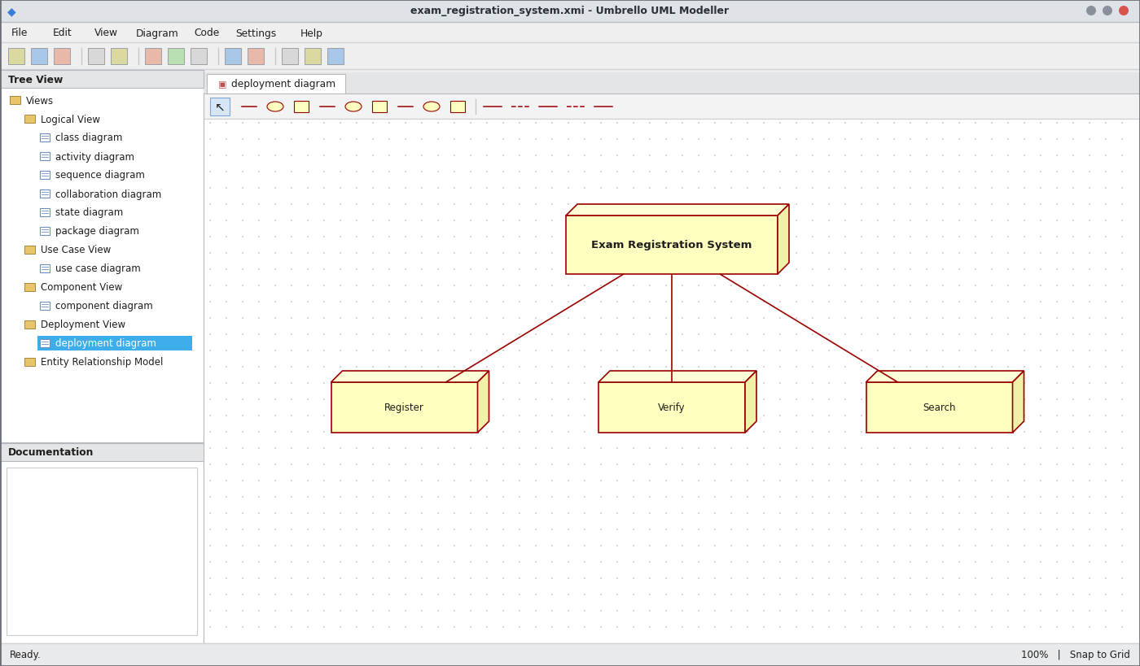
Deployment Diagram
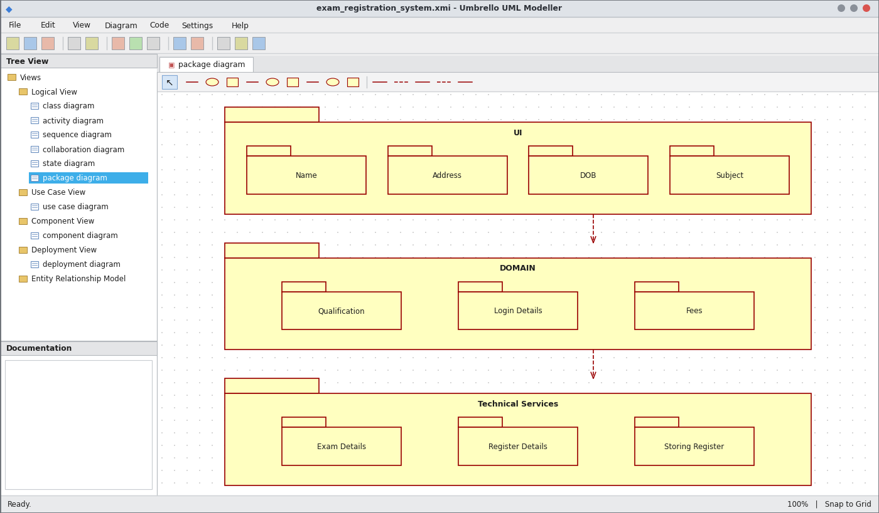
Package Diagram
WEBPAGE SCREENSHOT
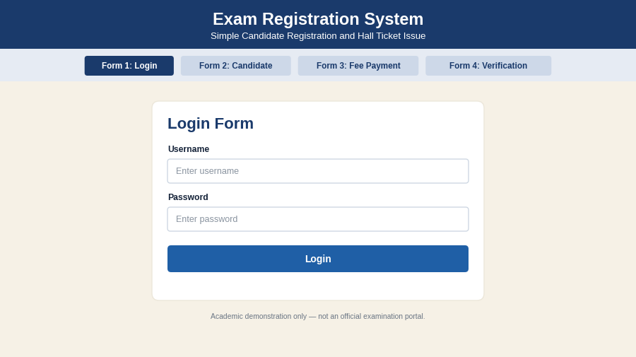
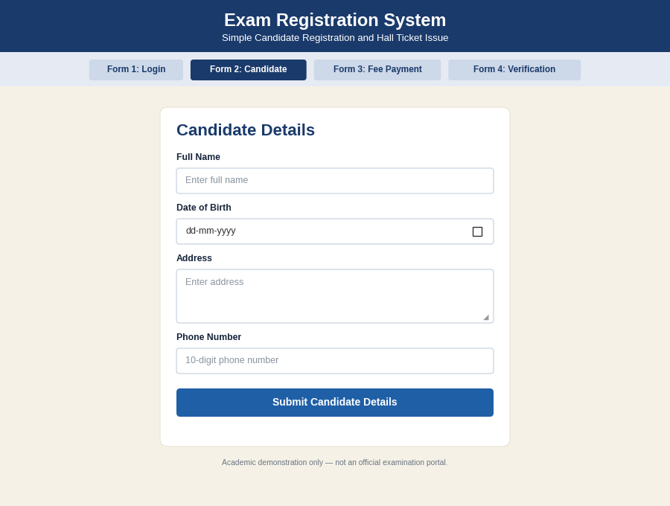
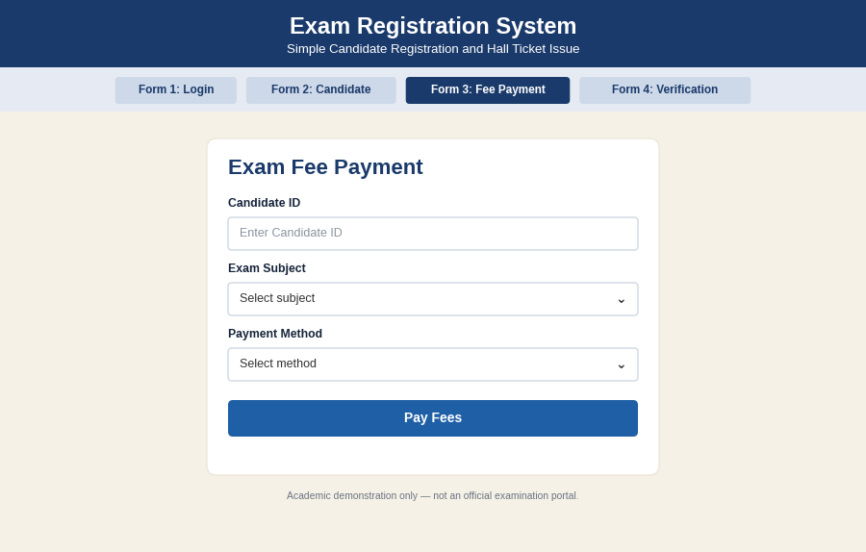
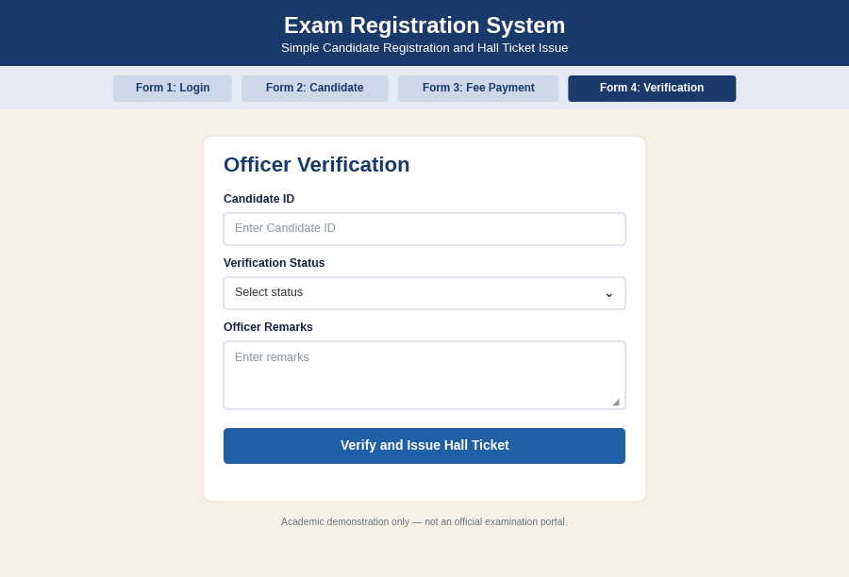
PSEUDO CODE
1. Login and Fee Payment
BEGIN
READ username and password
IF login is valid THEN
DISPLAY registration details and form
ACCEPT fee payment
ELSE DISPLAY "Login failed"
ENDIF
END
2. Form Filling and Verification
BEGIN
READ name, address, DOB, subjects, college
SEND registration parameters to website
CHECK details for fraud or duplication
IF details are correct THEN SET status = "Verified"
ELSE REJECT form
ENDIF
END
3. Storing and Acknowledgement
BEGIN
IF status = "Verified" THEN
STORE form in university database
DISPLAY registration acknowledgement
ISSUE hall ticket
ENDIF
END

EX NO: 4 STOCK MAINTENANCE SYSTEM
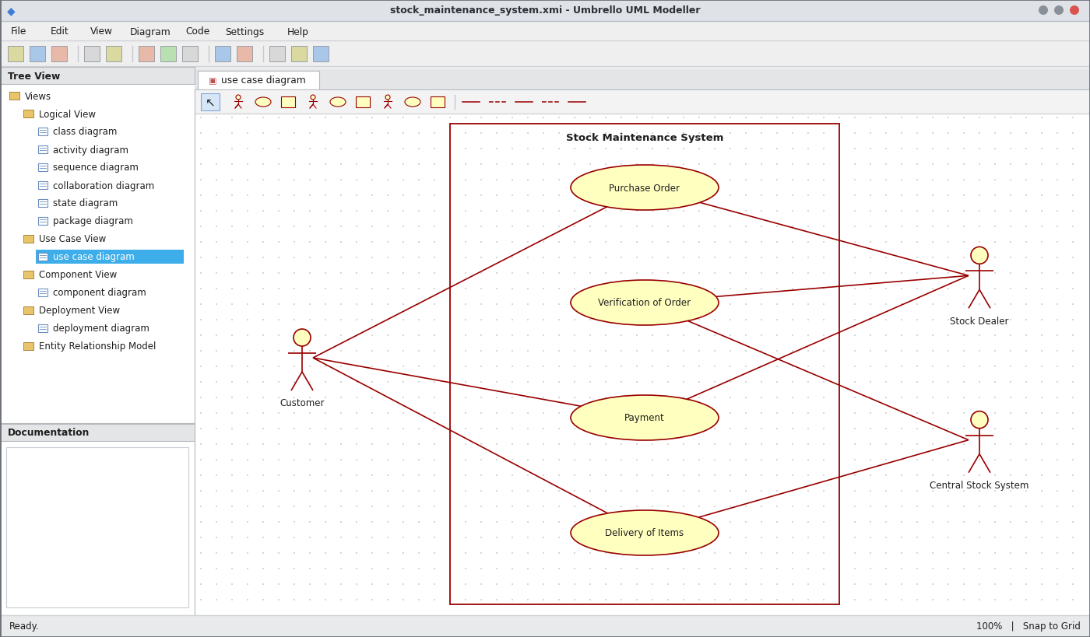
Use Case Diagram
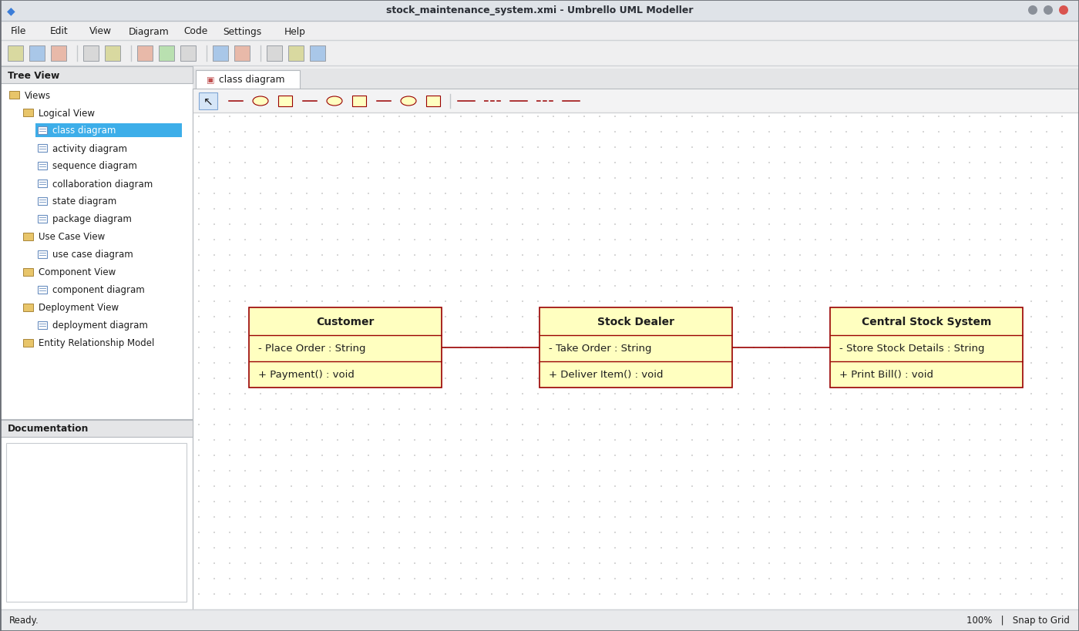
Class Diagram
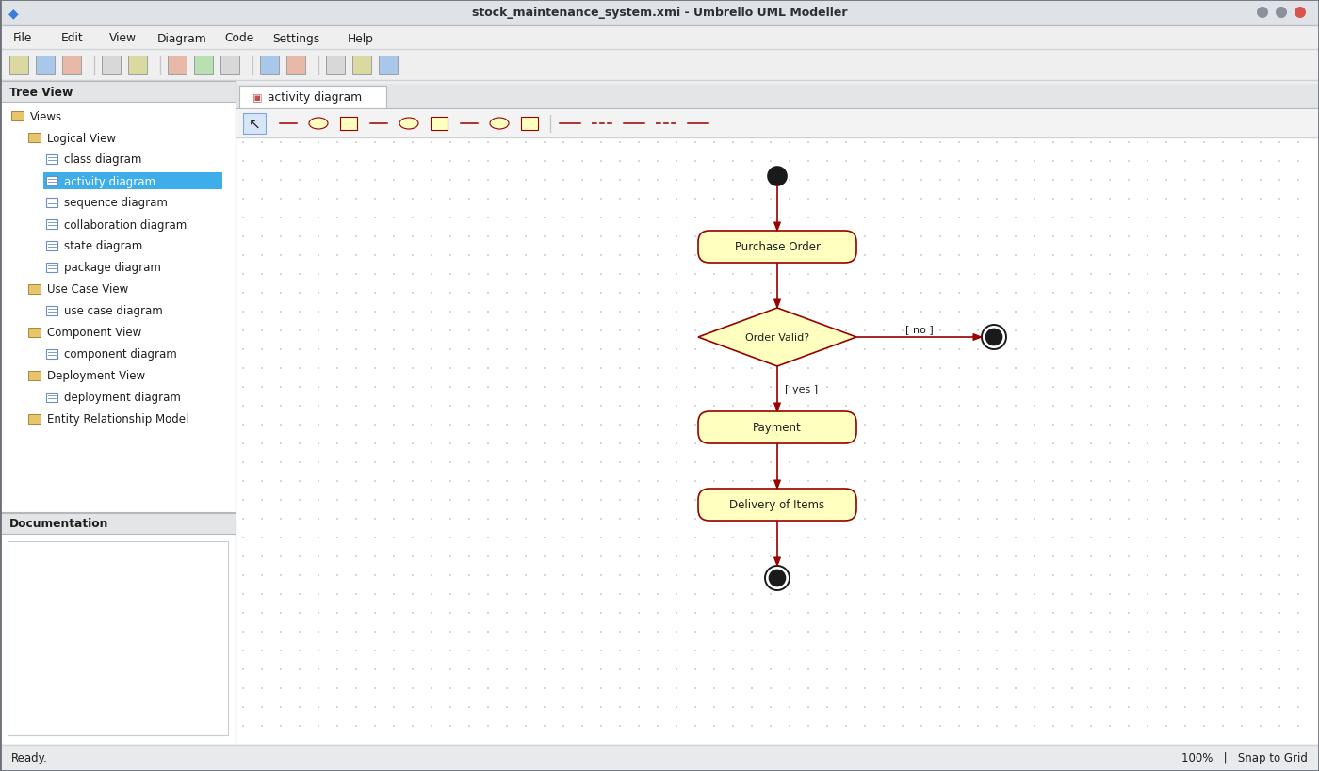
Activity Diagram
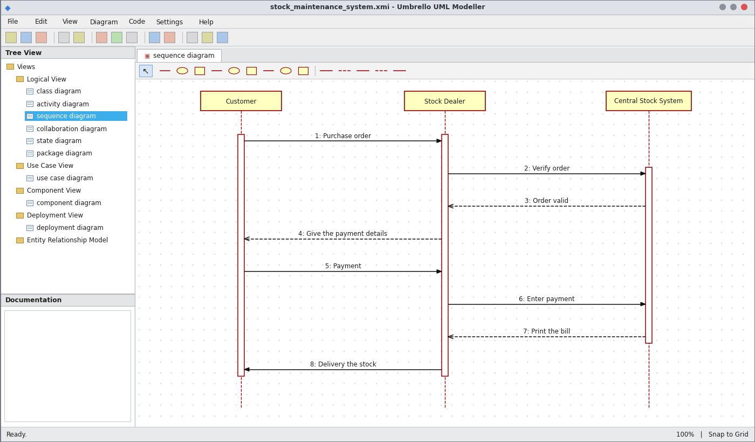
Sequence Diagram
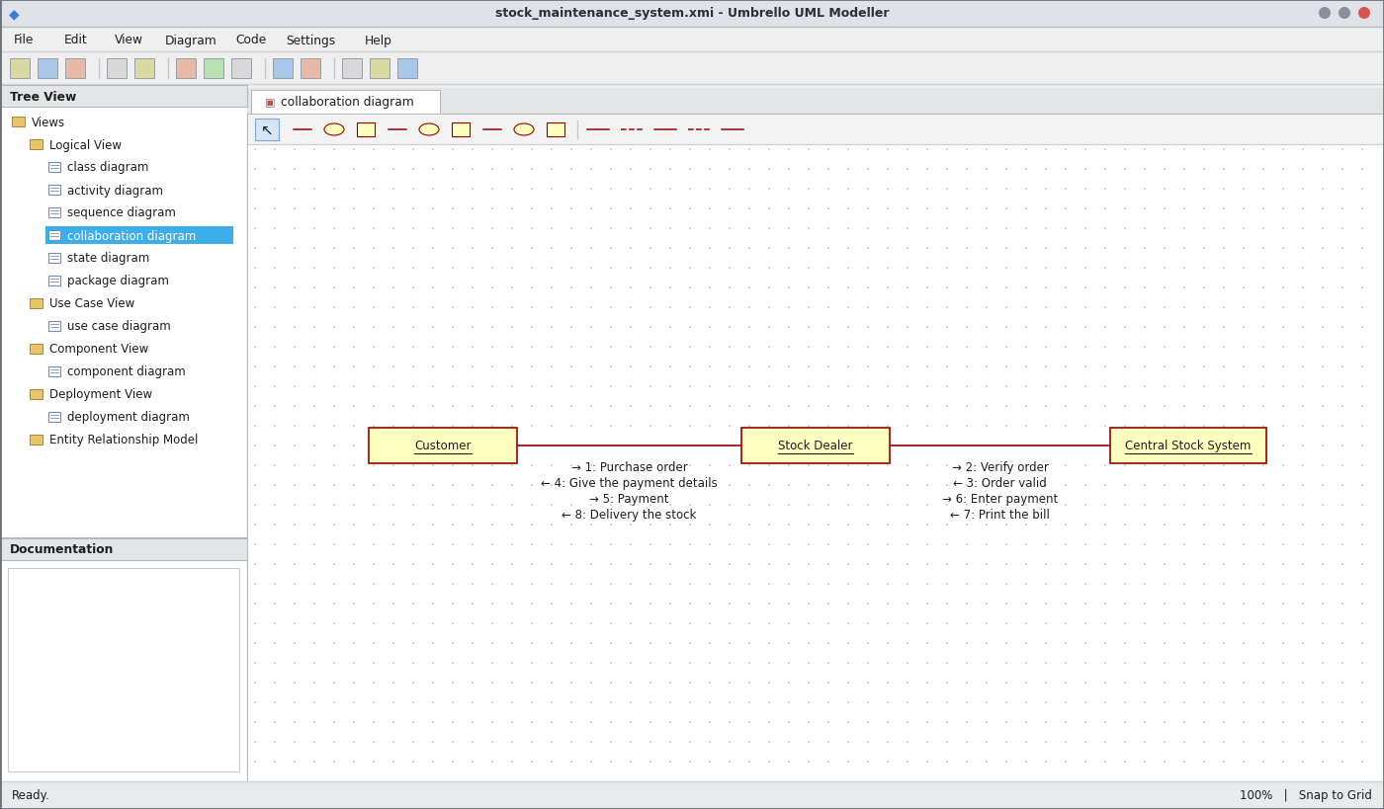
Collaboration Diagram
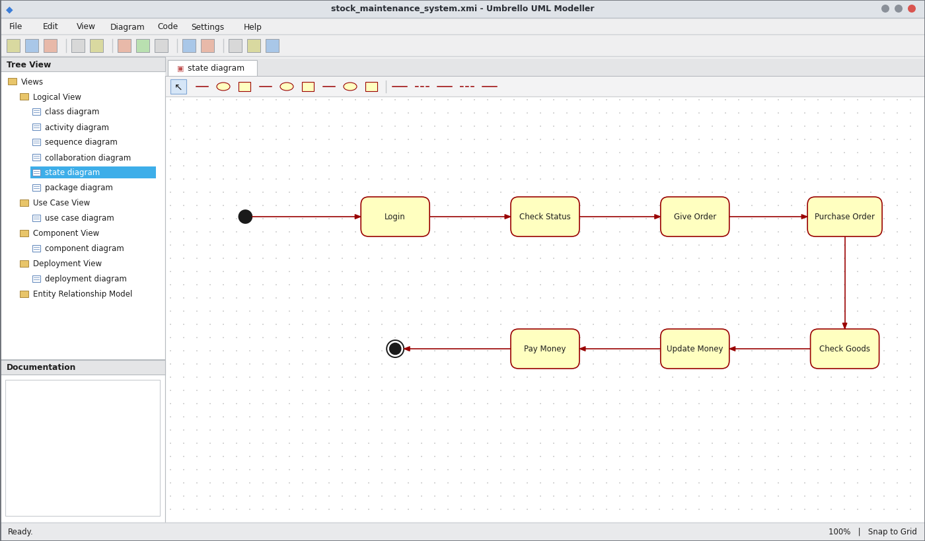
State Chart Diagram
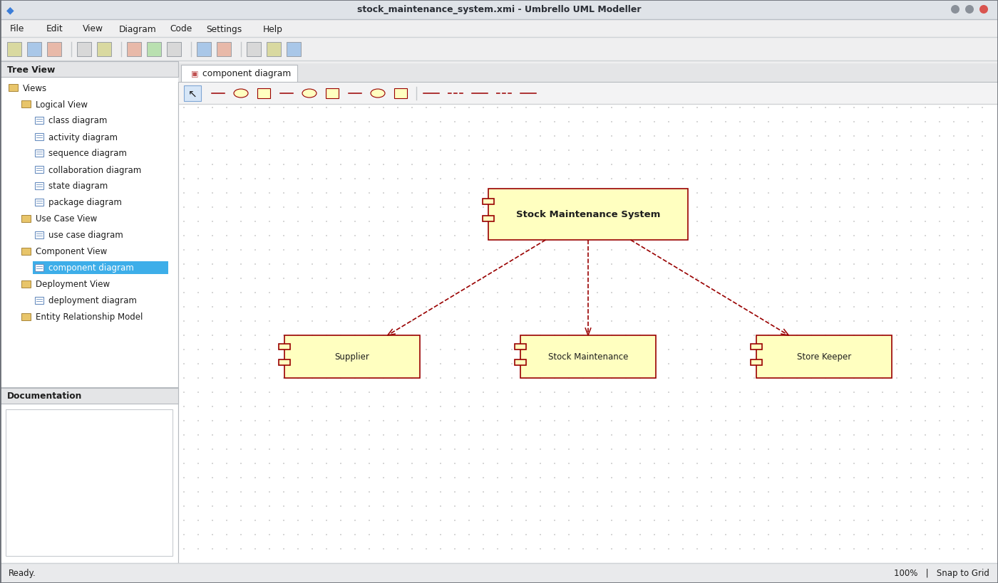
Component Diagram
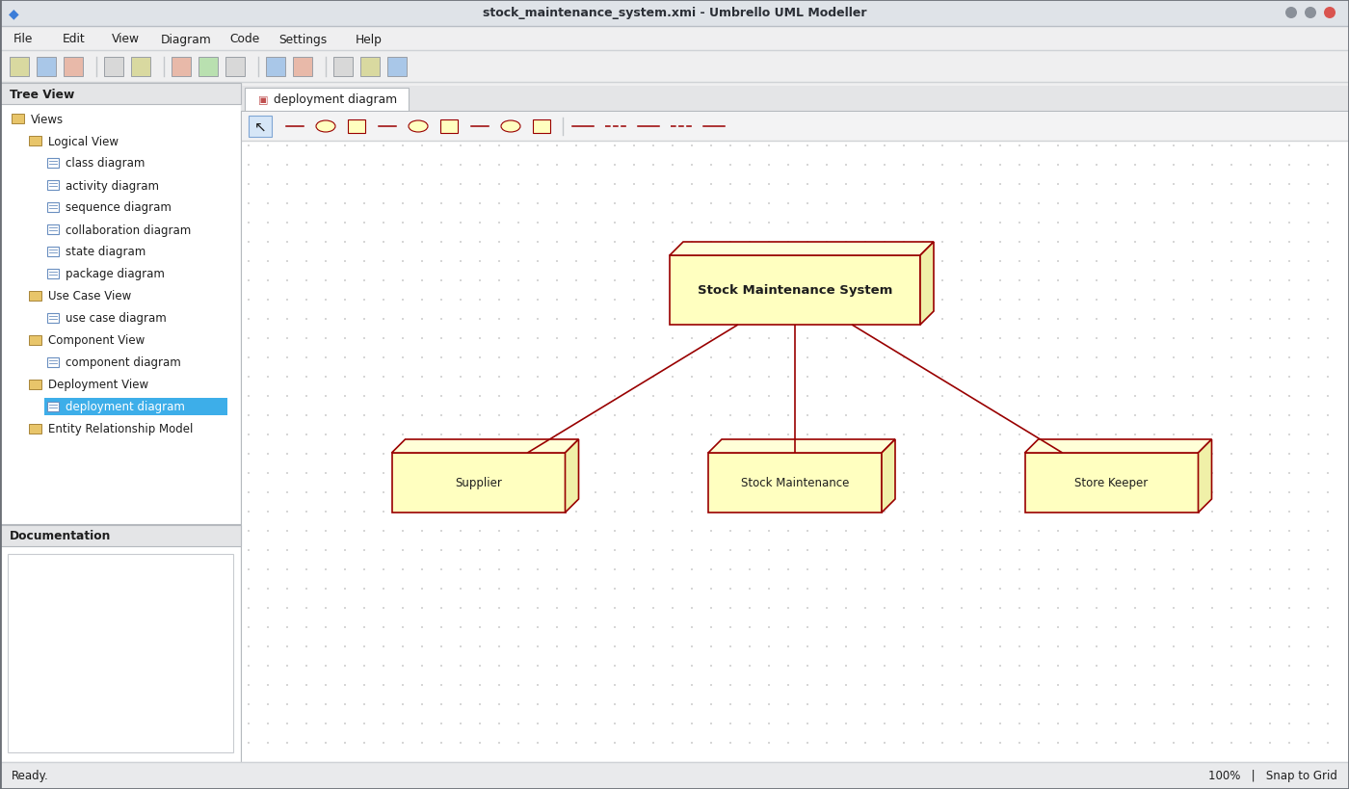
Deployment Diagram
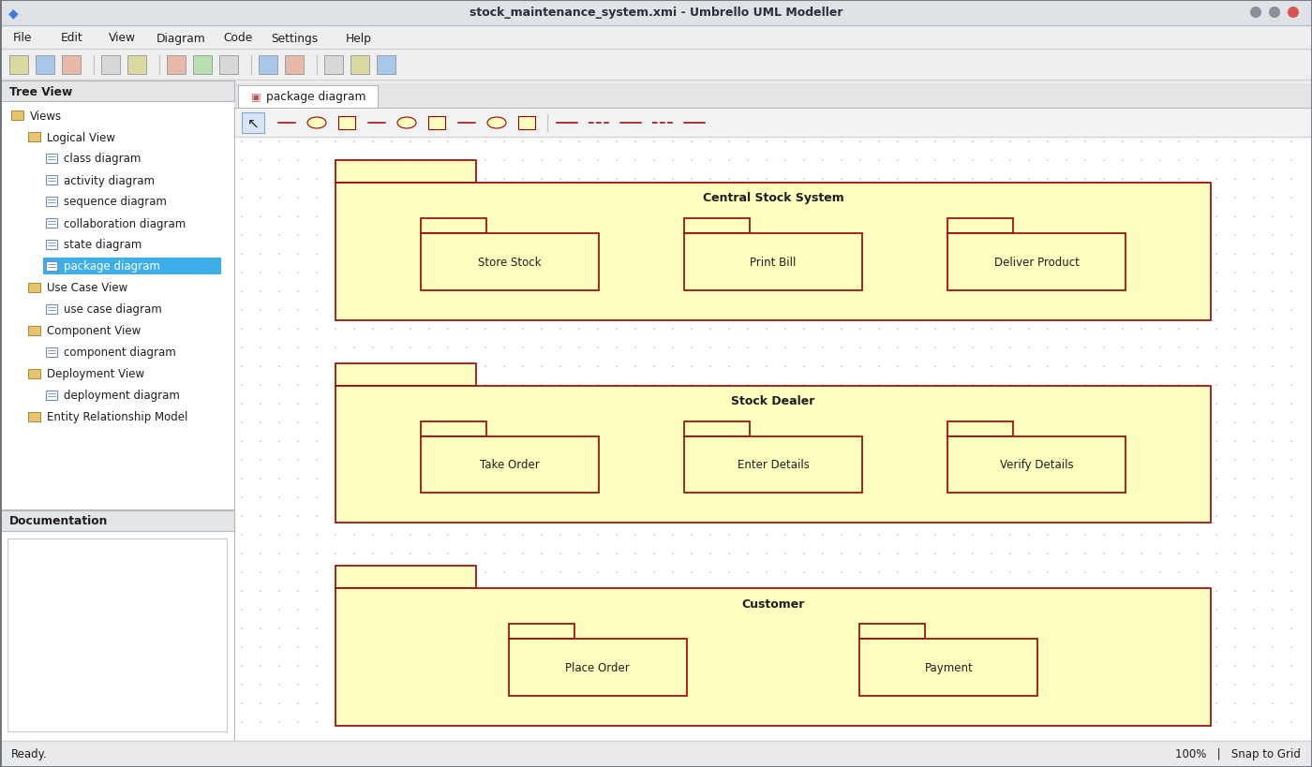
Package Diagram
WEBPAGE SCREENSHOT
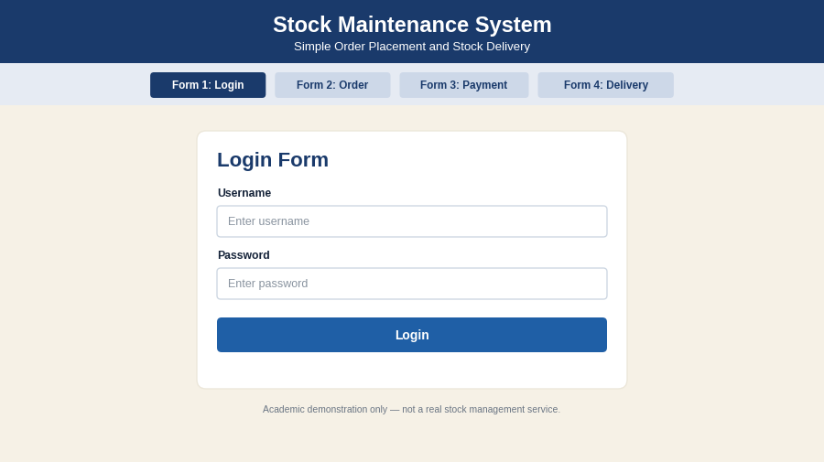
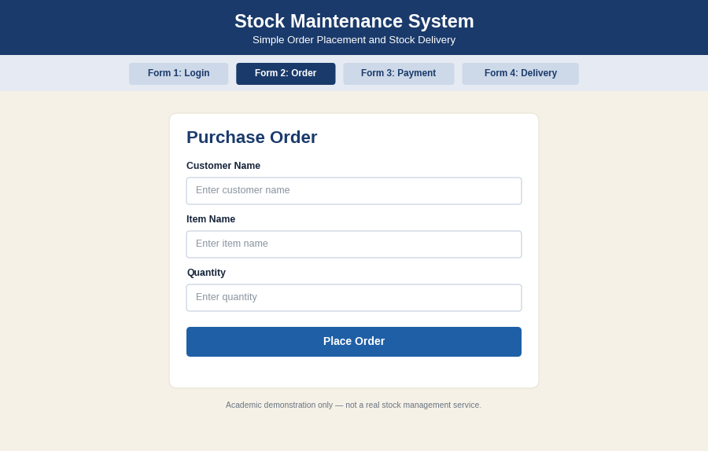
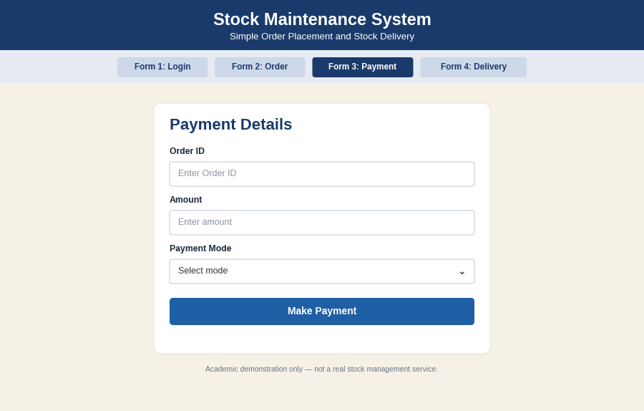
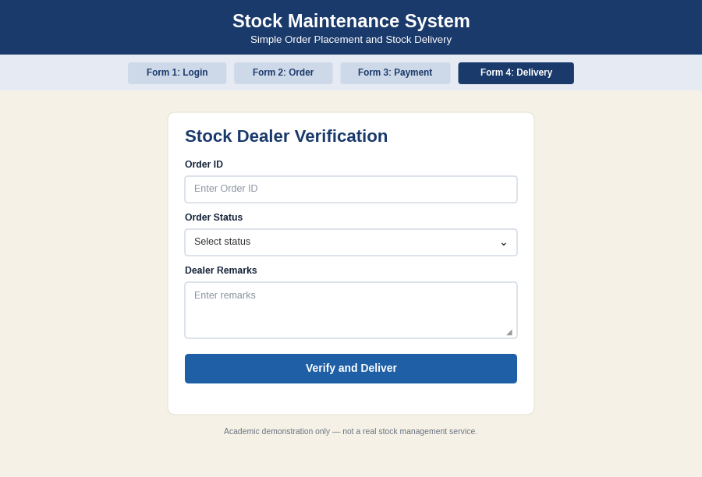
PSEUDO CODE
1. Purchase Order
BEGIN
CUSTOMER places purchase order
STOCK DEALER takes the order
SEND order to central stock system
IF order is valid THEN CONTINUE
ELSE REJECT order
ENDIF
END
2. Payment
BEGIN
DISPLAY payment details to customer
READ payment amount
ENTER payment in central stock system
PRINT bill
END
3. Delivery of Items
BEGIN
CHECK stock for ordered items
IF stock is sufficient THEN
DELIVER items to customer
UPDATE stock details
ELSE DISPLAY "Out of stock"
ENDIF
END

EX NO: 5 ONLINE COURSE RESERVATION SYSTEM
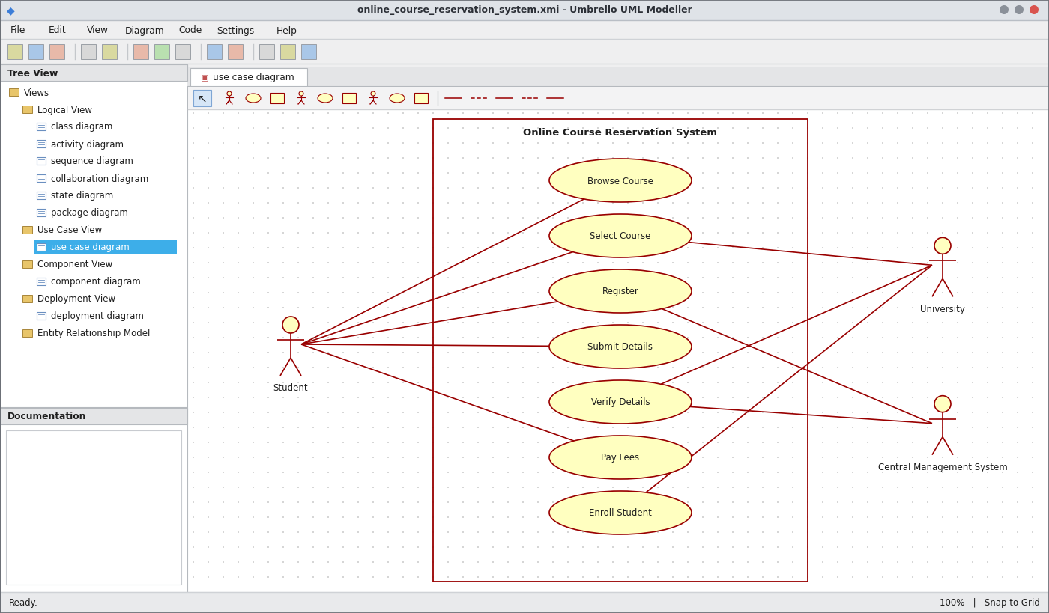
Use Case Diagram
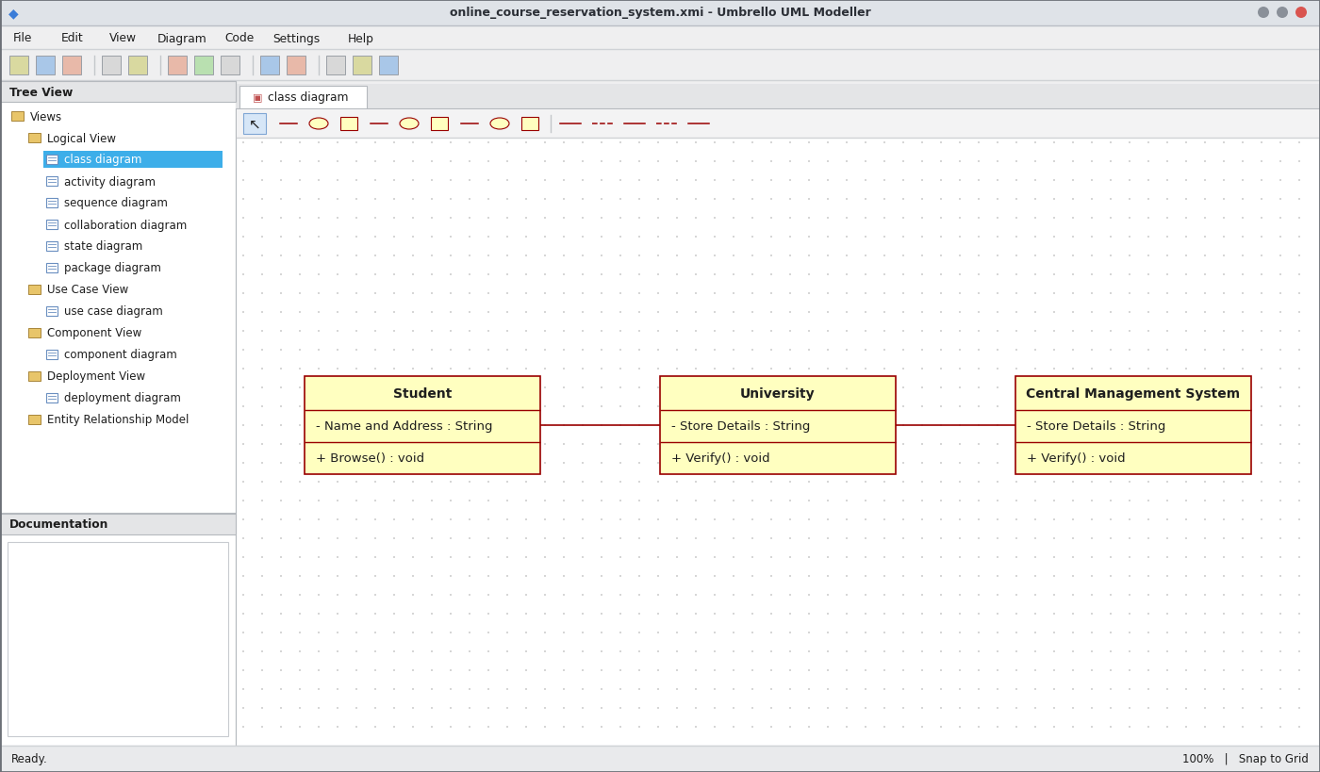
Class Diagram
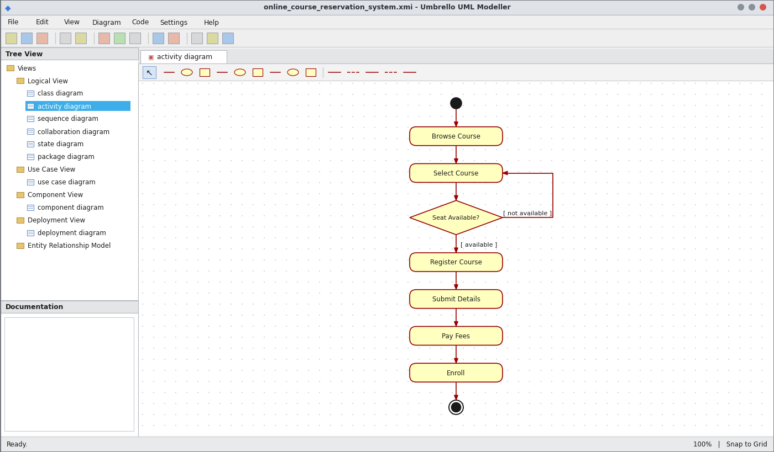
Activity Diagram
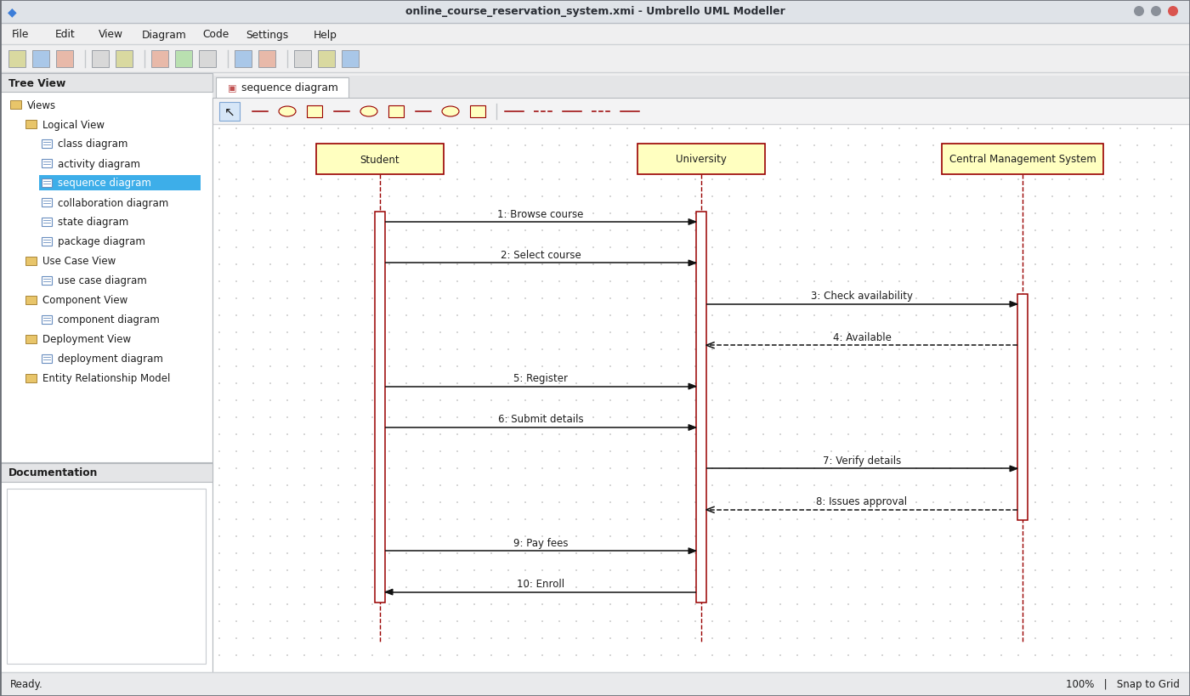
Sequence Diagram
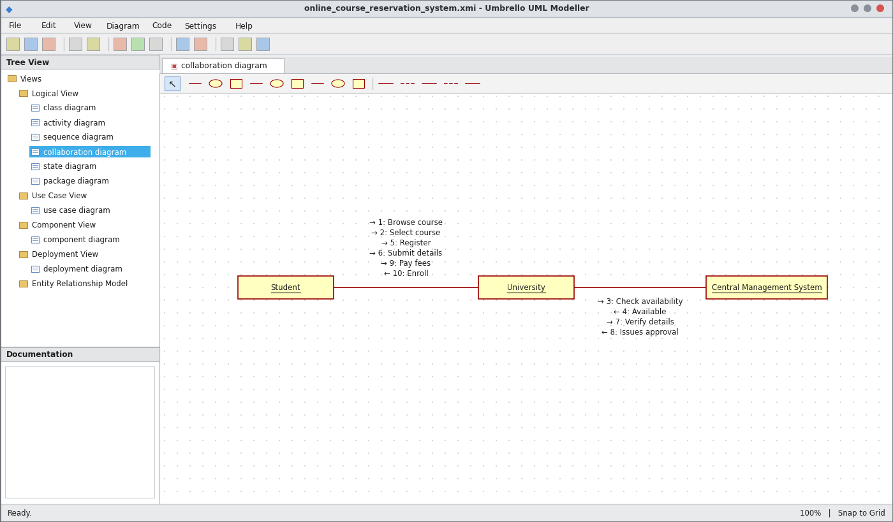
Collaboration Diagram
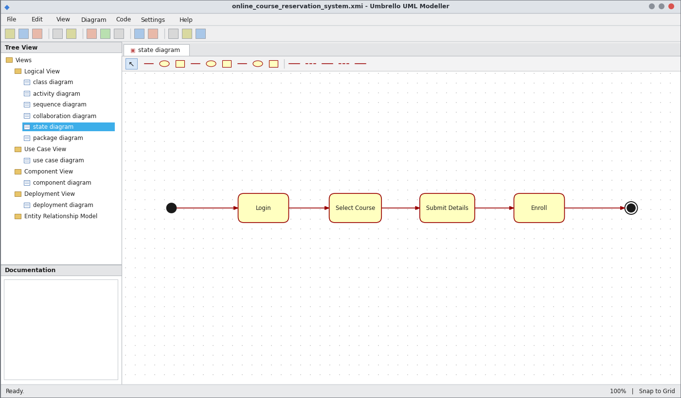
State Chart Diagram
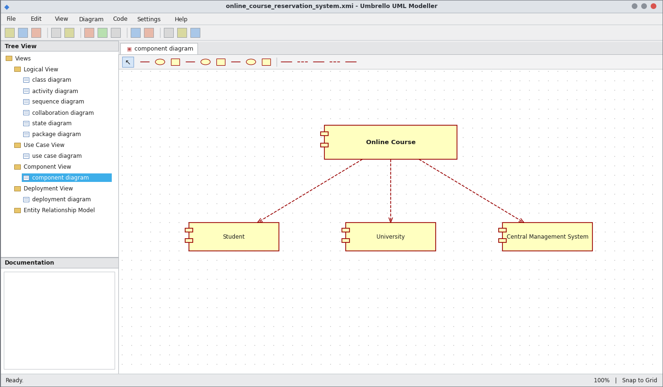
Component Diagram
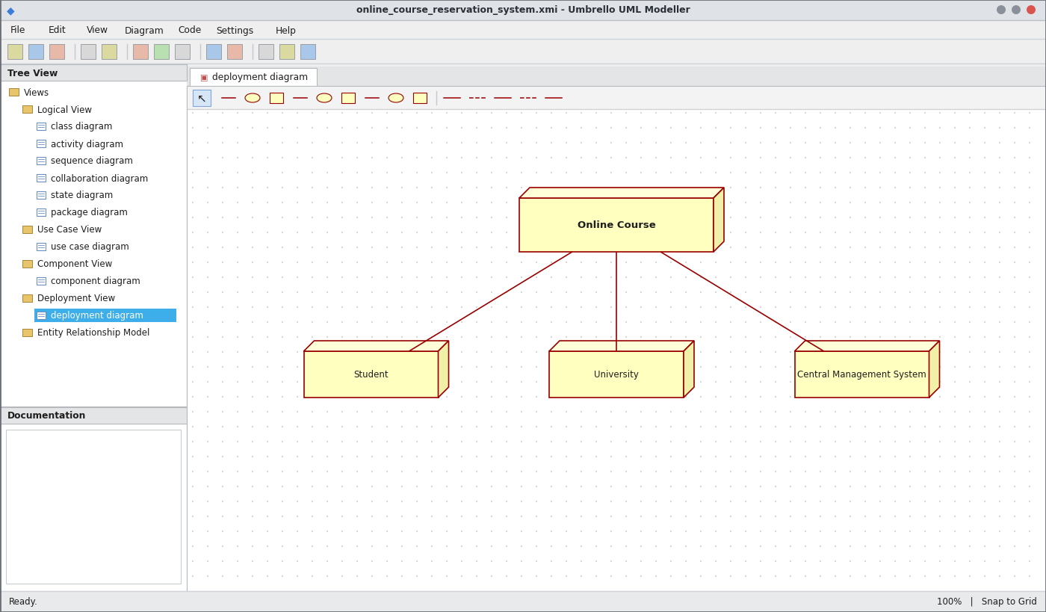
Deployment Diagram
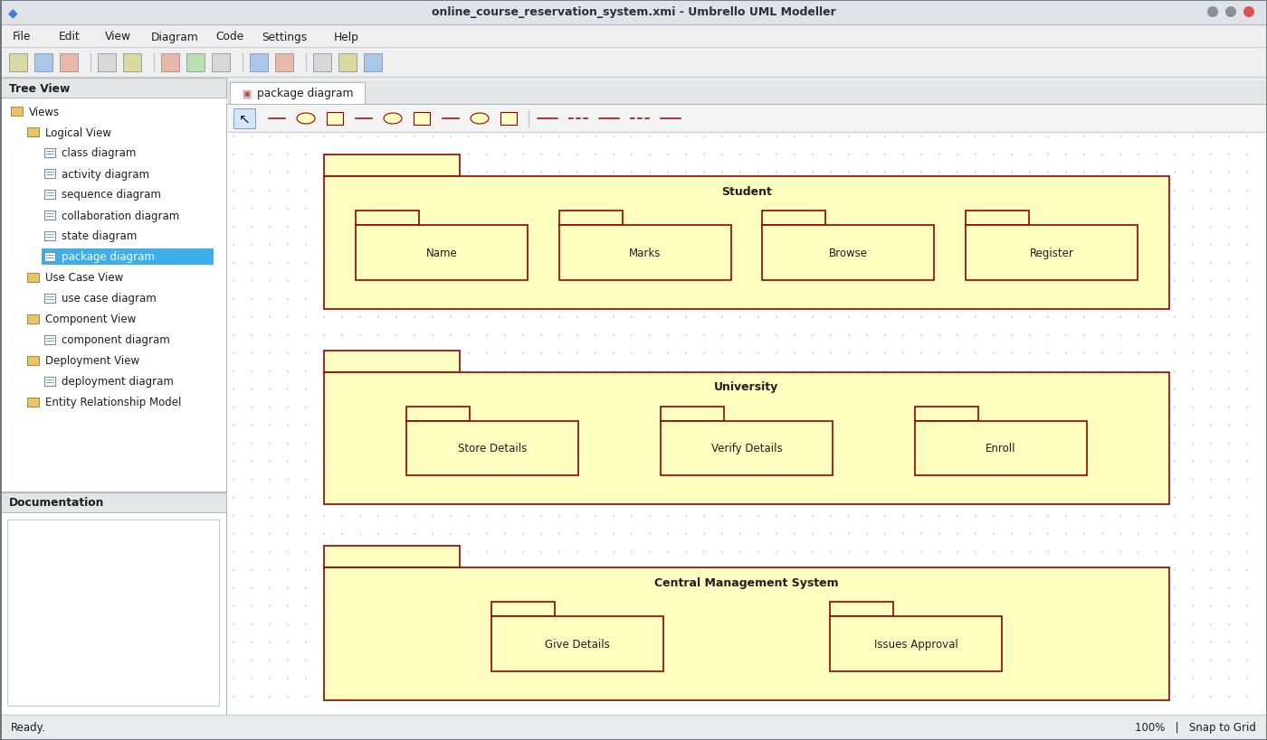
Package Diagram
WEBPAGE SCREENSHOT
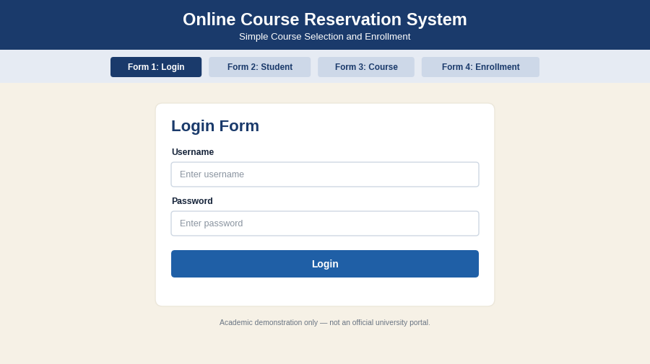
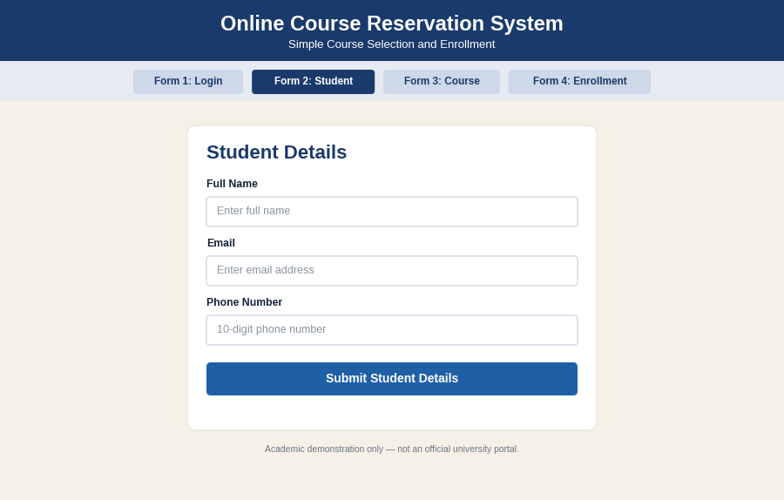
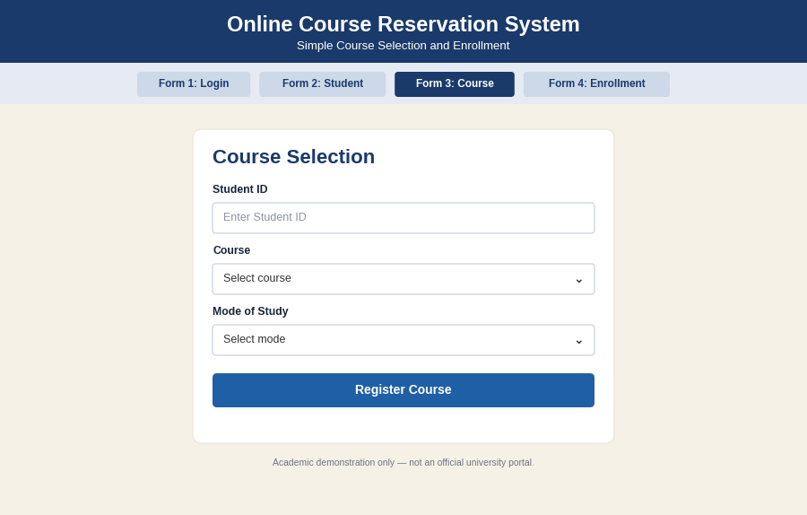
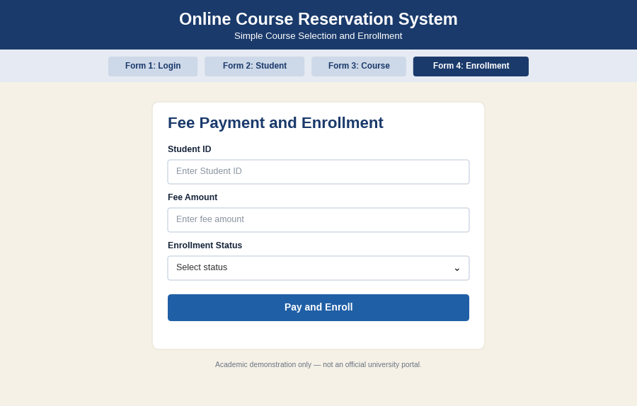
PSEUDO CODE
1. Browse and Select Course
BEGIN
STUDENT logs in
DISPLAY list of courses
READ selected course
SEND course to university
END
2. Check Availability and Register
BEGIN
CHECK seats for selected course
IF seat is available THEN
REGISTER course
READ and SUBMIT student details
ELSE
DISPLAY "Not available"; GOTO select course
ENDIF
END
3. Verify, Pay Fees and Enroll
BEGIN
VERIFY details with central management system
IF approval is issued THEN
ACCEPT fee payment
ENROLL student in the course
ENDIF
END

EX NO: 6 E-TICKETING SYSTEM
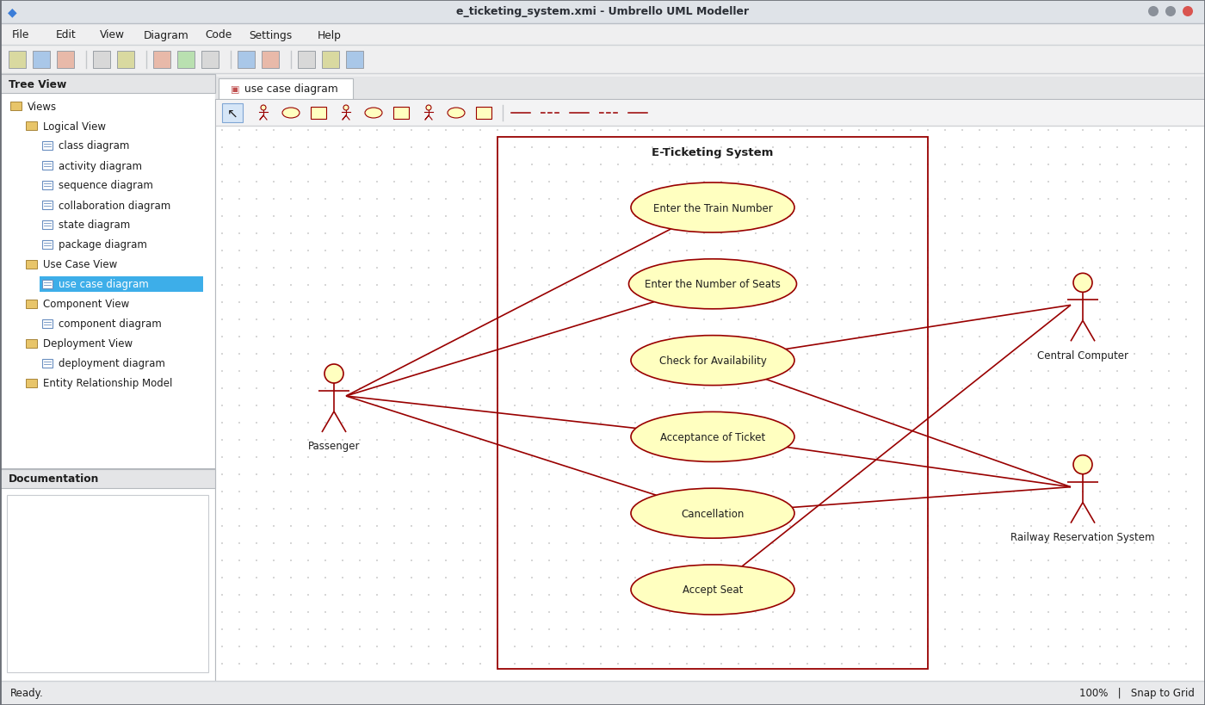
Use Case Diagram
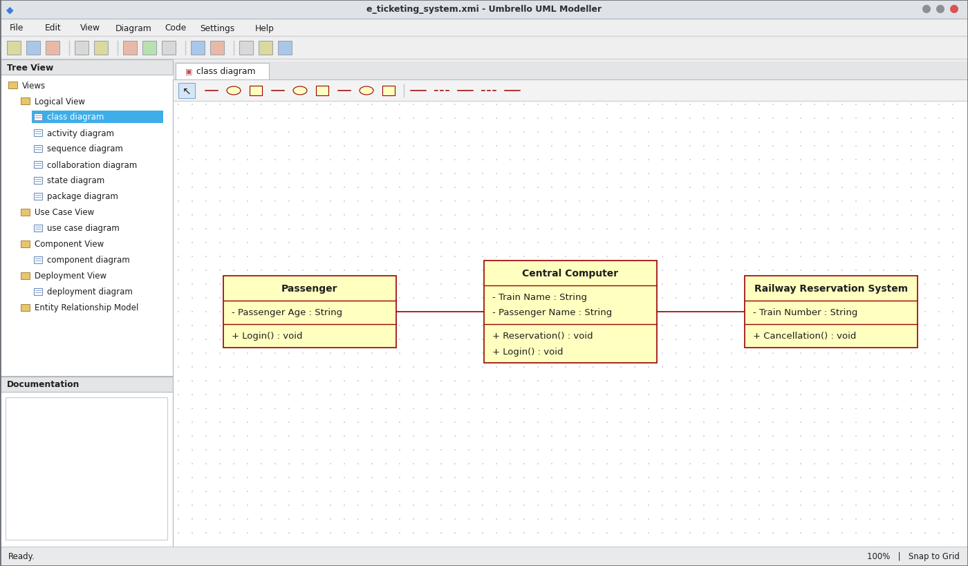
Class Diagram
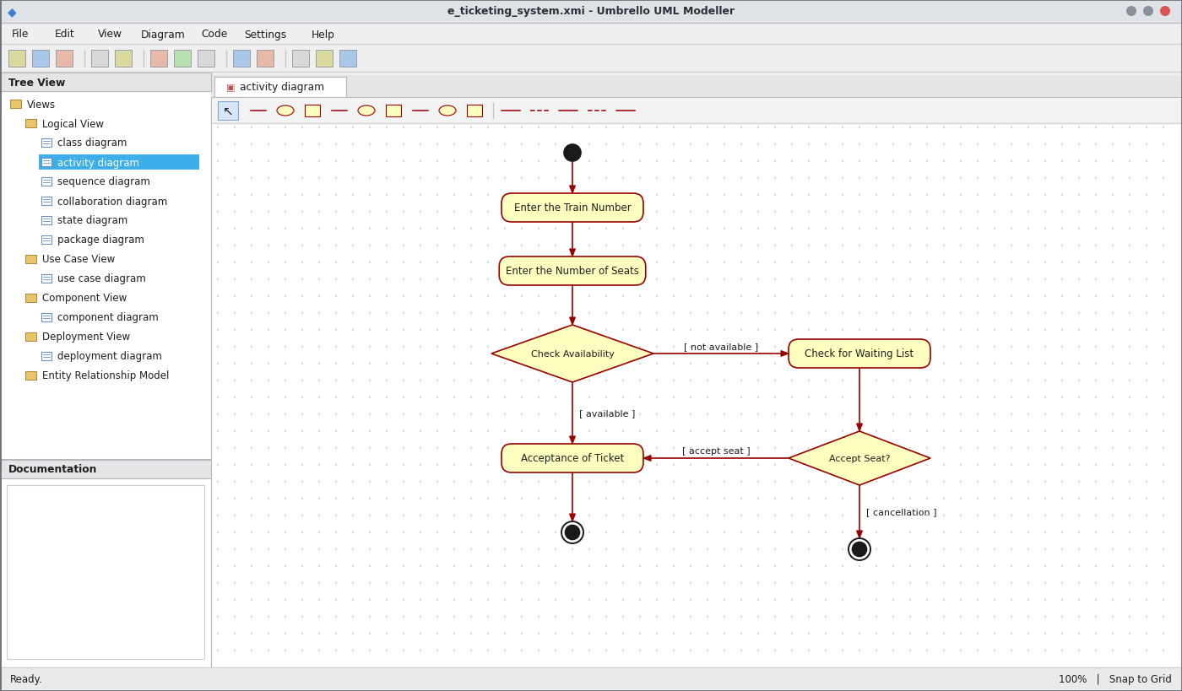
Activity Diagram
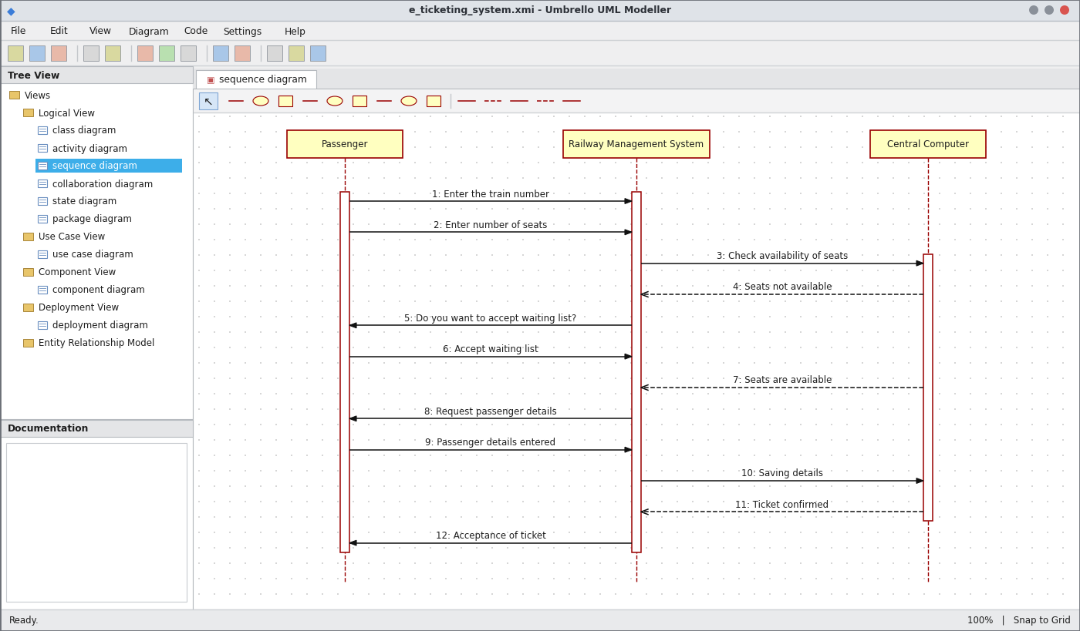
Sequence Diagram
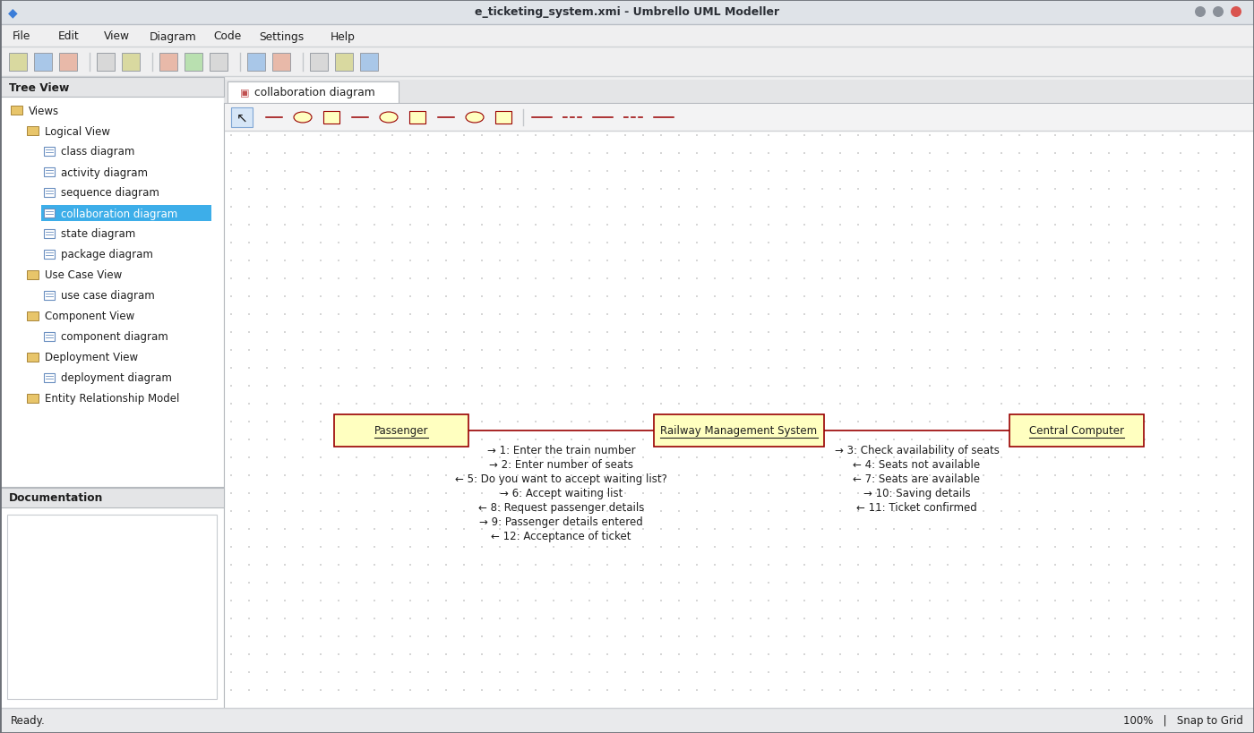
Collaboration Diagram
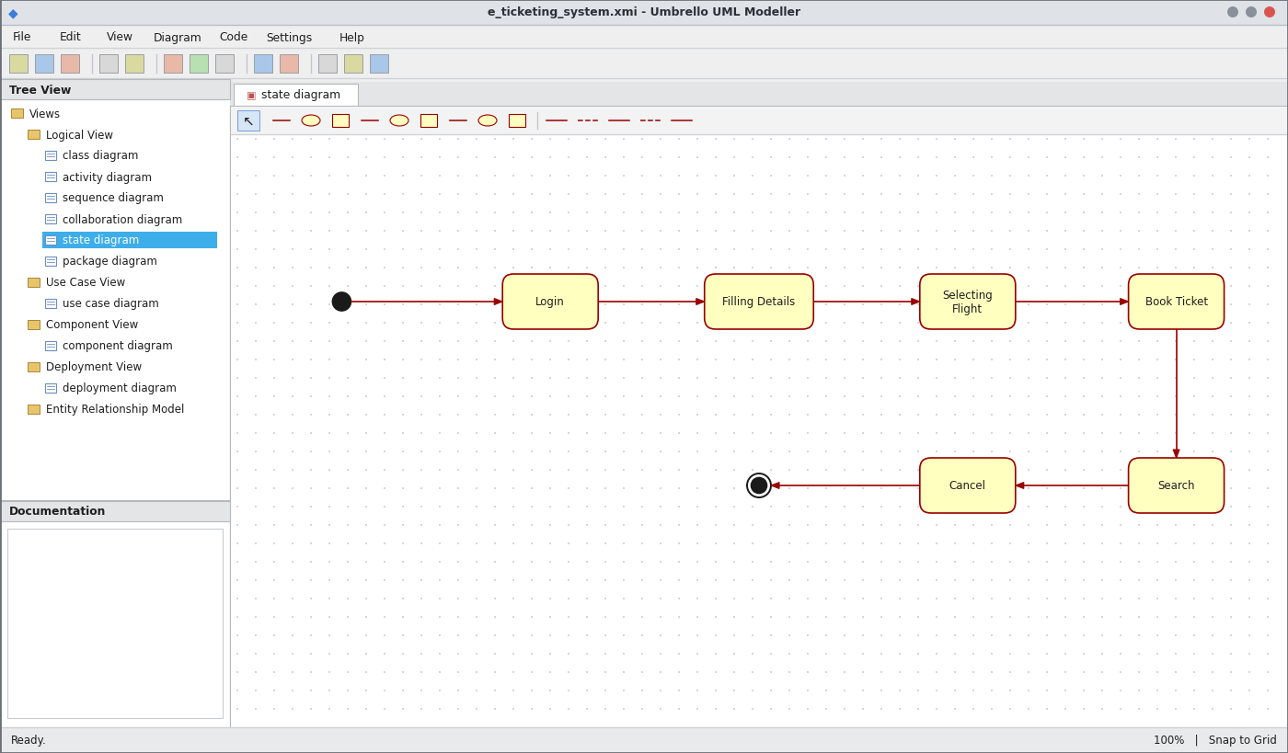
State Chart Diagram
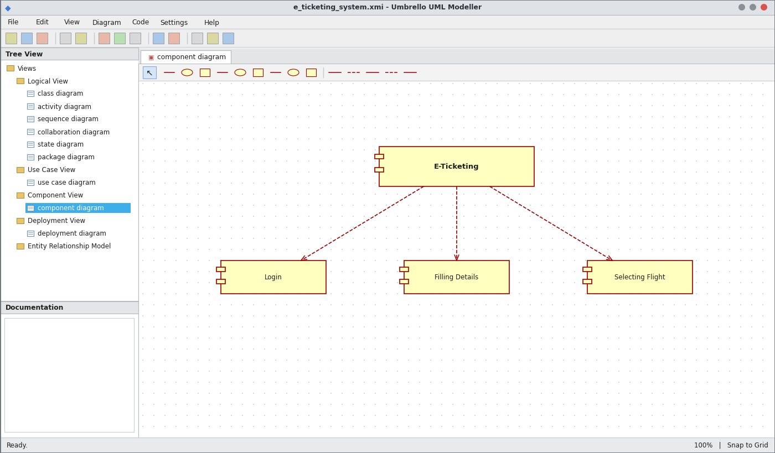
Component Diagram
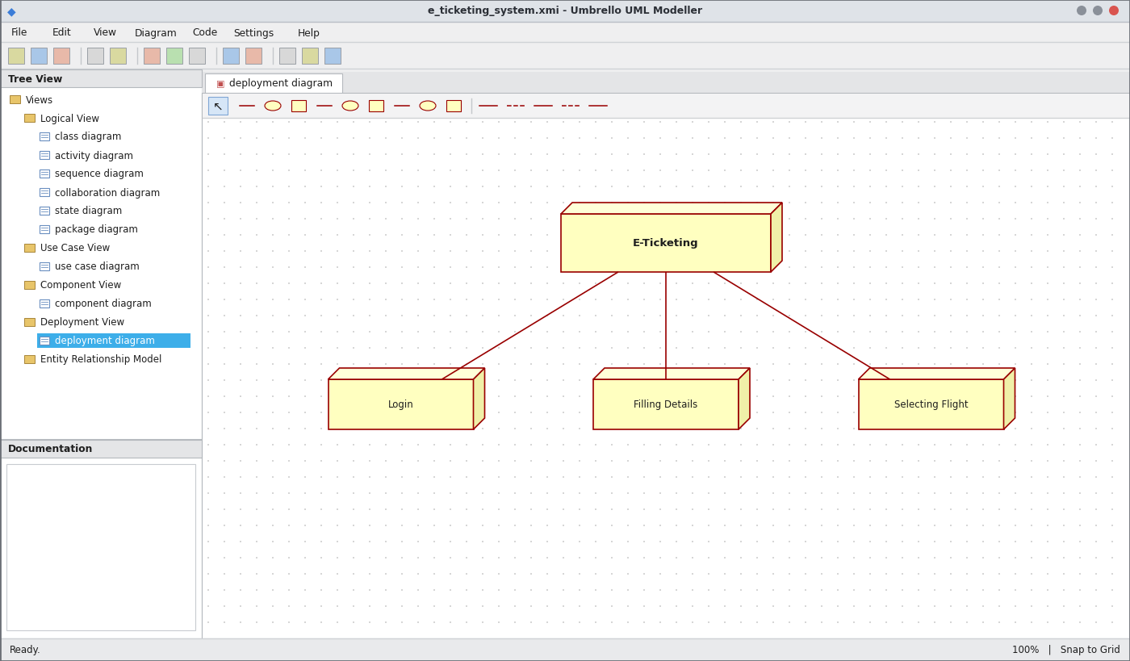
Deployment Diagram
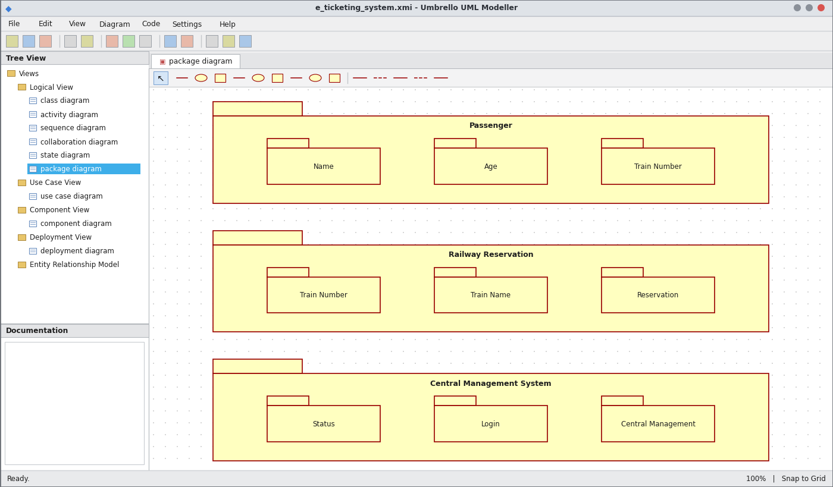
Package Diagram
WEBPAGE SCREENSHOT
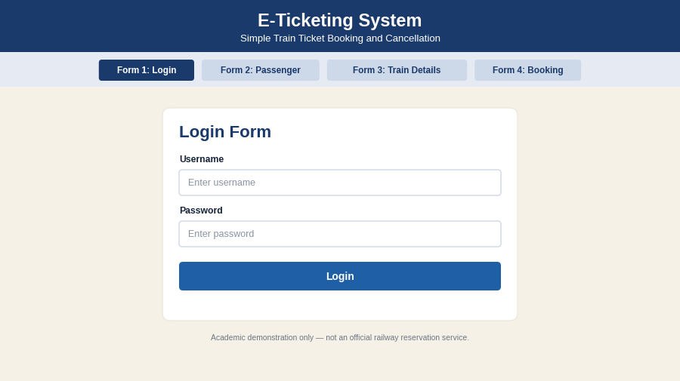
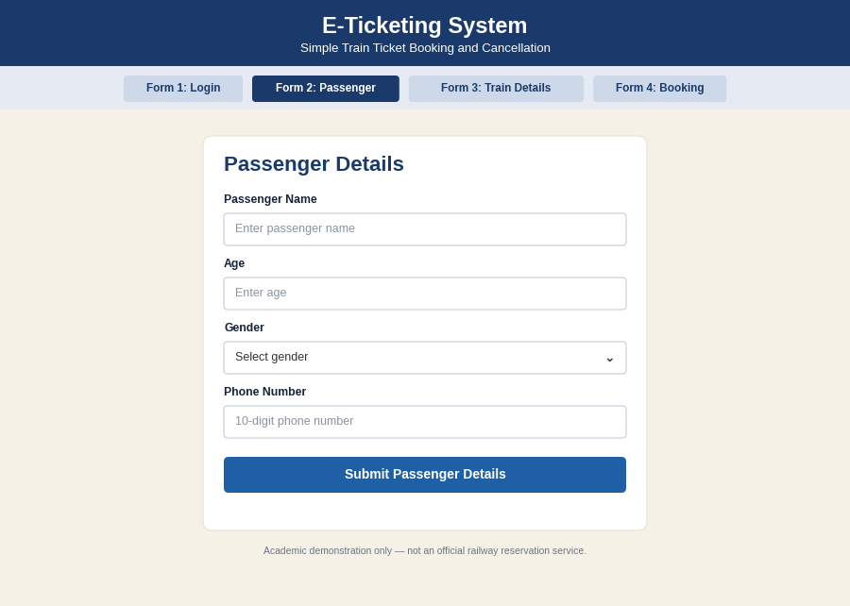
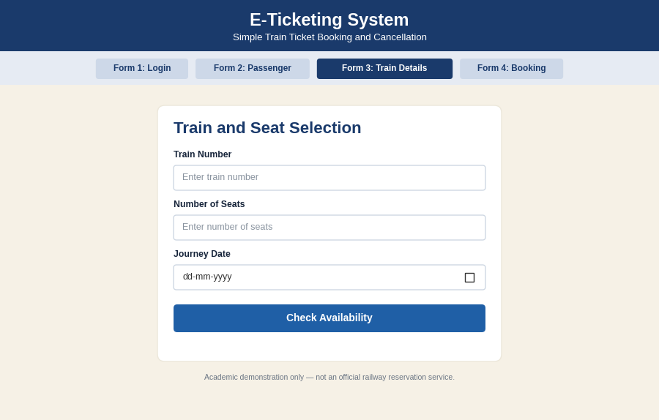
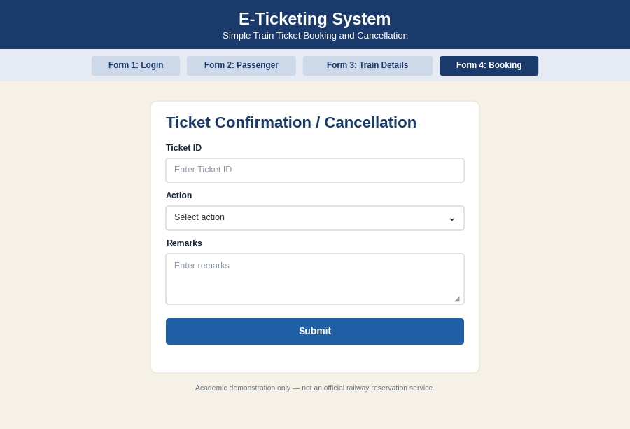
PSEUDO CODE
1. Login and Ticket Request
BEGIN
READ username and password
IF login is valid THEN
READ train number and number of seats
SEND request to railway reservation system
ENDIF
END
2. Check Availability
BEGIN
CHECK seats for the train
IF seats are available THEN CONTINUE to booking
ELSE
ASK "Accept waiting list?"
IF yes THEN ADD to waiting list ELSE CANCEL request
ENDIF
END
3. Book / Cancel Ticket
BEGIN
READ passenger details
SAVE details in central computer
CONFIRM ticket and SEND acceptance of ticket
IF passenger cancels THEN
CANCEL ticket and RELEASE seat
ENDIF
END

